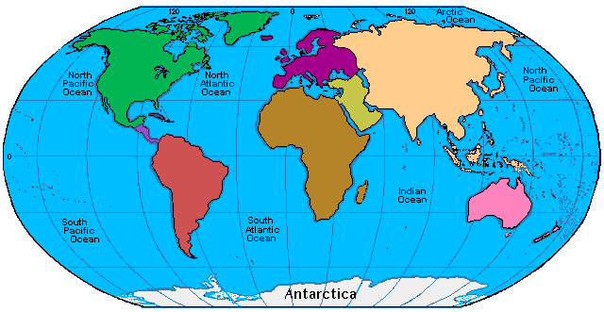
Mark Kohan
English Language Arts Teacher
& World Traveler
Morgantown, WV 26505
mark_kohan@yahoo.com

