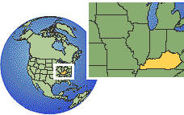
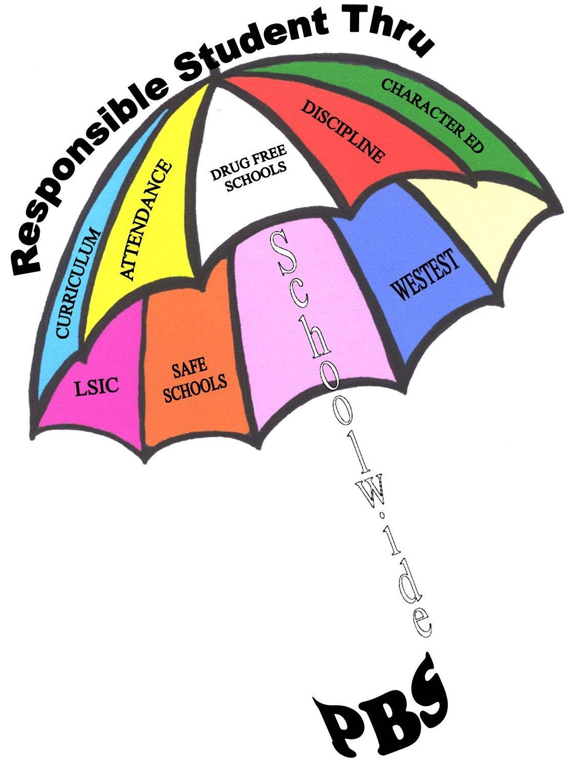

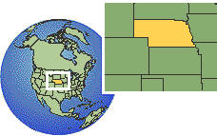
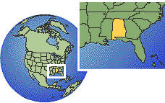

TriState
Consortium
Don to Florida
ATC
Coordinated
Team
ATC Circle of

Friends Presch.
RRTC
Not Funded
? New RRTC?
AS - Honer
CEC - Sugai
CEC
VanAcker
MSFA PBS & Wraparound
180 DOE Sch Wide teams
Life QuilteRs
Greenbrier Center
OBHS/
$ Medley Project
Mon. Co. Sch. Ind. PBS
ATC trained in Wood Co.
Life Quilters became PBS Project
PBS Required Training for MR/DD Waiver
ATC Trains
ATC Trains
Don Trains RESA III Ind. PBS
Ind. PBS/ Spec Ed Dirs.
Don Trains RESA III Ind. PBS
Don Trains RESA VIII & Hampshire Co. Ind. PBS
WVU Beh. Anal. Ind. PBS
WVU / MU / MUGC embed PBS
DOE Sch Wide initiated
Marion Co. Sch Wide initiated
Cadre

established
RESA 5/6 Sch Wide
N/S Sch Wide
RESA 1 Low Sch Wide
RSP & Sch Wide PBS Merged
WVU PBS Sped. Ed Courses
MUGC On-line PBS
WVU Sch. Wide PBS
RIDE Grants/Train
MU for HFA

