47th Friend E. Clark Lecture Series

sponsored by

Phi Lambda Upsilon Chemistry Honorary and
C. Eugene Bennett Department of Chemistry

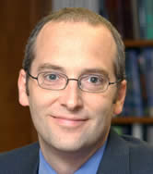

presents

Professor John F. Hartwig
Kenneth L. Rinehart Jr. Professor of Chemistry

Department of Chemistry
School of Chemical Sciences
University of Illinois at Urbana-Champaign

“The organometallic chemistry of metal-heteroatom bonds”
March 12, 2007, 5:00 p.m., Clark Hall 208

and

“Catalyst Design in Chemistry and Beyond”
March 13, 2007, 4:00 p.m., Hodges Hall 260

