Boron-Doped Diamond Electrodes for the Analysis of Trace Metals

A. Manivannan,¹ D. A. Tryk,² and A. Fujishima³

¹Department of Physics, West Virginia University, Morgantown, West Virginia 26505, U.S.A.
²Department of Chemistry, University of Puerto Rico, Rio Piedras Campus, San Juan, Puerto Rico 00931-3346
³Department of Applied Chemistry, School of Engineering,
The University of Tokyo, 7-3-1 Hongo, Bunkyo-ku, Tokyo 113-8656, Japan

Contents
- Introduction
  - Overview
  - General aspects of electrochemical metal analysis
  - General aspects of diamond electrodes
  - Overview of BDD electrodes for metal analysis
- Early Work on BDD Electrodes
  - Overview of bulk metal deposition
    - Lead, cadmium and platinum
    - Mercury and silver
    - Copper
  - Trace metal deposition
    - Mercury films on BDD
    - Mercury -free detection
- Recent Work
  - Single metal analysis
    - Lead
    - Mercury
  - Analysis of two or more metals
- Special Techniques
  - Rotating disk electrodes
  - Acoustic techniques
  - Microwave techniques
  - Abrasion techniques
- Future Prospects
- Introduction

  - Overview

In this Chapter, we review the topic of electrochemical trace metal analysis at the boron-doped CVD diamond electrode and try to indicate some of the possible advantages of the use of this type of electrode. We begin by briefly summarizing just the basic aspects of electrochemical metal analysis, then provide some background material on the general use of boron-doped diamond (BDD) in electrochemistry, and finally indicate the rationale for the use of BDD as an electrode material for metal analysis.

  - General aspects of electrochemical metal analysis

Trace metal analysis has been important for several decades due to growing concerns about their toxicity, and there is a great need to monitor them in a variety of matrices, including air, water, and soil, as well as in physiological tissues and fluids. The most hazardous heavy metals include lead, cadmium, mercury, arsenic, thallium and selenium. The toxic effects of these are diverse, going from the neurological effects of lead and mercury to the cardiovascular effects of cadmium. The presence of mercury, lead and cadmium in the workplace constitutes an occupational hazard that can lead to cancer [1-3] and heart diseases [4] respectively. Therefore, it is an important task to detect these types of metals and their quantities in all of the possible matrices. Mercury, arsenic, and selenium are natural pollutants, and their levels can be increased by human activity. For example, mercury is being continuously released into the atmosphere from coal-fired power plants [5]. Moreover, metals such as mercury, cadmium, and lead are all accumulated by fish in water [6],[7, 8].
The increasing awareness of public health problems related to heavy metal contamination of the environment has led to the development of a host of analytical techniques designed for their trace determination. These include atomic absorbance spectrometry (AAS), atomic fluorescence spectrometry (CV-AFS) [9], inductively coupled plasma-atomic emission spectrometry (ICP-AES) [10], and cold vapor atomic absorption spectrometry (CVAAS) [11]. Depending on the specific practical problem for trace analysis, several important factors need to be considered in choosing a particular technique, such as the required detection limits, the instrument cost, the analysis time, including sample preparation time, the sample matrix, and the type of location, e.g., laboratory or field. Even the preference of the individual analytical chemist, based on experience, is important. Moreover, these techniques can also complement each other. In situ monitoring of trace metals is an attractive option for such applications as industrial process control and water quality control.
Electrochemical stripping analysis is an attractive, powerful tool for detecting trace metals due to its simplicity and sensitivity in the simultaneous measurement of multiple elements at detection levels from ppb to ppt. In addition, the added features of portability, low power requirement, and the suitability for automatic on-line monitoring emphasize its great power for rapid, inexpensive analysis of trace metals in applications such as field-testing.
The detection of trace elements by anodic stripping voltammetry is a well established electroanalytical technique, in which the accumulation of the metals at the electrode plays a major role in the improvement of detection limits [12-14]. The electrode is first maintained at a potential at which the metal or metals of interest are expected to deposit. Then, the potential is swept in the positive direction in order to oxidatively dissolve the deposited metals. In the simplest implementation of this technique, the potential sweep is an unadorned potential ramp. In many cases, however, one or another type of pulse program is used. The pulse variables include the nature of the excitation wave-form (pulse, differential pulse, square wave) and its amplitude, and the current sampling regime. These variables determine the specific voltammetric method, e.g., differential pulse stripping voltammetry (DPSV), and Osteryoung square-wave stripping voltammetry (OSWSV). A comparison of the various electroanalytical techniques shows that stripping voltammetry is usually several orders of magnitude more sensitive for trace metal analysis than the others [15]. The specific example shown in Figure 1 is for DPSV.
T₁
T₁
T₁
T₂
T₂
T₂
ΔVs
ΔVp
P_{w}
T
TIME
Potential
Figure 1. Wave form for differential pulse voltammetry (DPV) where ΔV_{s}= step height, ΔV_{p}= pulse height, P_{w} = pulse width, with the current being sampled at times T₁ and T₂.
In the anodic stripping voltammetry (ASV) of metals in aqueous solution, the metal ionic species are first deposited (reduced) electrolytically onto an inert electrode at a constant applied potential. As a specific example, we show schematically what happens when we deposit Pb²⁺, Cd²⁺, Cu²⁺ from solution as Pb, Cd, and Cu (Figure 2).
As already mentioned above, a potential ramp is then applied in the positive direction, which will cause the deposited metals to be
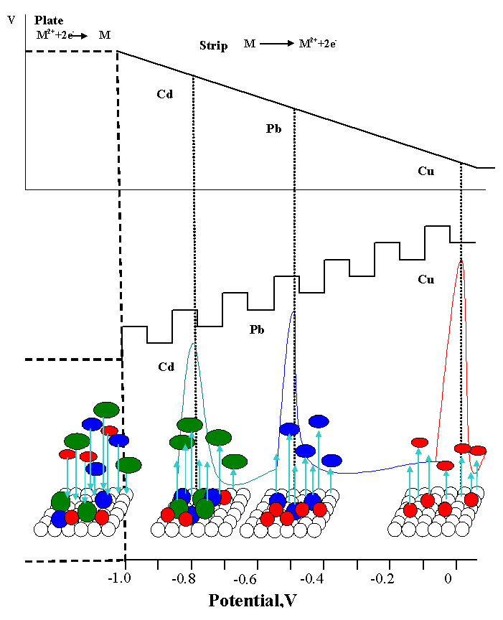
Figure 2. Schematic representation of the deposition and stripping of Cd, Pb and Cu.
stripped (oxidized) from the electrode at characteristic potentials, E_{p}. Also, as already mentioned, rectangular voltage pulses with adjustable pulse height and width are usually imposed on this voltage ramp. This allows the separation of the charging current from the Faradaic current component, which is proportional to the concentration of the analyte. Since E_{p} is different for different species, simultaneous detection of several metallic species is possible. Clearly, for the technique to work properly, the species must adhere to the electrode surface and be in electrical contact with it.

  - General aspects of diamond electrodes

Pure, undoped diamond is a good insulator (resistivities in the range of 10¹⁰ to 10¹² Ω cm) [16], with a large band gap (5.4 eV), and therefore it is not immediately usable as an electrode material in electrochemistry. It has long been recognized that boron doping of diamond single crystals, either natural or synthetic, [17] leads to semiconducting behavior, because the boron introduces an acceptor level at 0.37 eV above the valence band edge. If the doping level is increased, the acceptor level widens to form a band, which can eventually approach within a few meV from the conduction band, at which point the material becomes metallic [18]. Based on the pioneering work of Angus and coworkers [19], it became possible to produce electrically conductive boron-doped diamond films by use of the chemical vapor deposition (CVD) technique, providing conductivity sufficient for electrochemical and sensor applications. The use of diamond electrodes in electrochemistry was pioneered by Iwaki et al. [20]and Pleskov et al. [21, 22]. In the work of Fujishima and Tenne and their respective coworkers, the potential of diamond in electrolytic processes was demonstrated [23-25]. However, the work of Swain and coworkers was the first to demonstrate the great potential of BDD electrodes in analytical electrochemistry [26]. These workers showed that BDD provides a number of advantages over carbon, glassy carbon, and metal electrodes. These include i) an order of magnitude lower background current density, ii) a large potential window (as much as 4 V in aqueous solution), which allows the resolution of many different species, iii) very low capacitance, which results in relatively small charging current, thus providing higher sensitivity, and iv) chemical inertness and stability without any pretreatment.

  - Overview of BDD electrodes for metal analysis

Given these superior characteristics, we have long believed that BDD electrodes could be useful in electrochemical trace metal analysis. A particularly attractive feature was envisioned, i.e., the avoidance of the use of mercury. As it has turned out that, this feature is not without complications, although the original idea is indeed viable. We will show in the next section that it was not immediately obvious that the anodic stripping technique could even be used at BDD electrodes, because early work on metal deposition had shown that it was difficult, if not impossible, to strip deposited metals from this surface.
In the work of our group, as well as other groups that have joined this effort, two broad technical objectives can be considered: (i) to develop the technique of electrochemical detection of trace metals to less than 10⁻¹⁰ M levels in aqueous solution using BDD electrodes; and (ii) to adapt the technique for the rapid quantification of trace metals at distributed and/or remote locations. Attainment of these objectives will aid the development of effective trace metal control strategies through the development of effective trace metal monitors.
Indeed, in our early experiments using BDD electrodes, we were able to detect 10⁻⁹ M levels of Hg, Pb and Cd [27-30]. Because of their electrochemically robust character, BDD electrodes are able to withstand much higher voltage pulse amplitudes and faster potential sweep rates compared to other electrodes. It has also been shown that BDD electrodes are much less prone to interferences such as those due to adsorption than conventional electrodes [31].

- Early Work on BDD Electrodes

  - Overview of bulk metal deposition

    - Lead, Cadmium and Platinum

Peilin et al. were among the first to propose that BDD should be a good candidate for an electrode material for electroanalysis in harsh chemical environments [32]. These workers examined voltammograms for lead and cadmium using both KCl and KNO₃ electrolytes at diamond electrodes in the presence of mercuric nitrate and compared the results with those obtained with glassy carbon electrodes. They also showed a two-month period stability for the voltammetric response of lead at diamond electrodes. The electrochemical deposition of Pt, Pb and Hg adlayers on conductive diamond thin film electrodes has been studied by Swain et al. using cyclic voltammetry and scanning electron microscopy [33]. These results indicate that electrochemical metallization of diamond film surfaces is feasible, leading to the possibility of the development of novel catalytic electrodes, sensors, and detectors (Fig. 3).
The lead deposition was performed using cyclic voltammetry in a solution of 1 mM lead nitrate solution in 0.1 M HClO₄. The deposition current starts during the potential scan in the negative direction, and continues to flow at less negative potentials on reversal
of the scan direction, as a current crossover is observed. This behavior is characteristic of a nucleation and growth type of deposition mechanism. Further scanning in the positive direction yields a stripping peak due to oxidation of the deposited lead, indicating a
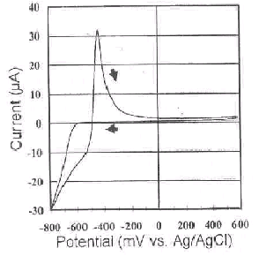
Figure 3. Cyclic voltammogram (CV) for a diamond thin film in 1 mM Pb(NO₃)₂ + 0.1M HClO₄. Scan rate = 10 mV s⁻¹. Electrode area = 0.2 cm².
surface-controlled oxidation reaction. A scanning electron microscopic (SEM) image revealed that the Pb was deposited into large clusters rather than as a uniform dispersion over the surface. Anodic stripping voltammetric studies for lead and copper were also reported at mercury-coated diamond films using flow injection analysis. The authors stated that improvements in the response could be achieved with (i) pretreatment or activation of the diamond surface, and optimization of the (ii) mercury layer thickness, and of the (iii) deposition time and flow rate. Goeting et. al. reported on lead deposition as a means of obtaining information on the properties of diamond films grown on graphite substrate [34]. Electrochemically active areas may be detected with ex situ and in situ microscopy as a way to correlate the morphology and activity of the electrode material. Figure 4 shows the cyclic voltammetric response for three consecutive scans obtained for 1 mM lead in 0.1M HClO₄.
The deposition of lead occurs at -0.65 V vs. SCE, and the cathodic current reaches a plateau. On the positive sweep, cathodic current continued to flow until a potential of -0.49 V vs. SCE was reached, the onset of anodic current, indicating that the deposited lead was being stripped. The Pb deposition becomes slower with each cycle, and the peak current of the corresponding stripping response also decreases. This behavior is characteristic of a nucleation and growth process, in which microscopic particles deposit instead of a film. SEM and AFM studies were also carried out in order to try to understand the nature of the lead deposits. In situ AFM studies using1 mM lead in 0.1 M HClO₄ indicated the growth of lead particles after 6 min of deposition time at -0.8 V vs. SCE and complete coverage of the surface after 16 min. Applying 0.66 V vs. SCE for 1 min removed the deposited particles completely. It was suggested that new substrate materials other than graphite should be used. Wang et al. incorporated Pt particles in boron-doped diamond films by co-depositing 10-500 nm Pt particles and proposed that the Pt particles
Figure 4. Cyclic voltammetric response for three consecutive scans obtained for 1 mM lead in aqueous 0.1M HClO₄ at a boron-doped diamond film electrode.
at the surface were in electronic communication with the current-collecting substrate through the BDD matrix. The dispersed Pt particles were extremely stable, as no loss in activity was observed after 2000 potential cycles [35]. Gao et al. have prepared and characterized silver, copper, gold, palladium and platinum metal nanoparticles on diamond surfaces, by means of a simple solution immersion, and characterized them by Raman, SEM, XPS and X-ray diffraction techniques. They also explained that the diamond/silicon interfacial ohmic contact is the critical factor for achieving the observed spontaneous metal deposition, demonstrating a novel route for depositing nanometer-size metal catalysts on a highly corrosion-resistant diamond support [36].

    - Copper

Nakabayashi et al. showed that the electroreduction of Cu²⁺ forms submicrometer clusters in an electrolyte solution instead of depositing on the electrode, even though the electron transfer reaction itself forms copper metal as the reduced product [37]. Negligible anodic current is observed, because only a trace of the reduced copper remains on the surface, and this fraction is stripped at high overpotentials, as observed for Ag [38] and Pb [39] electrodeposition on diamond electrodes. A comparison of cyclic voltammograms obtained in aqueous 1 mM copper sulfate at platinum and diamond electrodes is shown in Fig. 5.
Evidence for the formation of copper clusters in the electrolyte was provided by Mie scattering [40], which was measured as a function of the cathodic charge passing at the diamond electrode. It was concluded that the potential cycling produces small particles of reduced copper metal that scatter light. It was also argued that copper atoms hardly adsorb on the diamond electrode surface due to the non-polar nature of the hydrogen-terminated surface. Zak et al. investigated the stripping/deposition processes in selected electrolyes on BDD thin films using electrochemical atomic force microscopy (EC-AFM) under potentiostatic control and discussed the ability to form

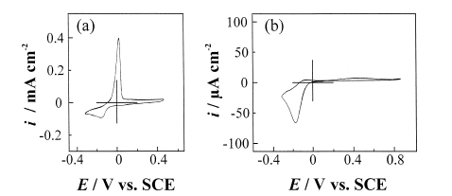
Figure 5. A comparison of cyclic voltammograms obtained in aqueous 1 mM copper sulfate at platinum and diamond electrodes.
complexes [41]. The analysis of the electrode surface topographic profile observed while the potential was switched between oxidative and reductive values indicated the nucleation stage and the early stages of complex formation, when cations are released from the deposited metal. The distribution of surface active sites is also discussed based on these experiments. In sulfate and phosphate solutions, an unusual increase in the deposited layer thickness is observed at positive potentials, in contrast to an expected decrease due to stripping. The observed effects of copper complex formation and its effect on the AFM tip position were explained using the model shown in Fig. 6.
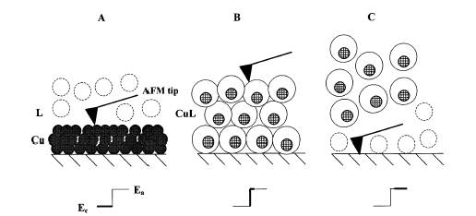

Figure 6. Model explaining the observed effects of copper complex formation and its effect on the AFM tip position.

In (A), the metal layer is formed due to the deposition of copper metal at reducing potentials, and as soon as the potential is switched to an oxidizing value, copper ions are released and the ligands immediately start to surround the ions to form complexes, thus increasing their size (B). This in turn causes a sudden deflection of the AFM tip, leading to the diffusion of the complexes away from the surface (C).

2.1.3. Silver and Mercury

Vinokur et al. reported a mechanistic study of mercury and silver deposited electrochemically on boron-doped diamond electrodes and concluded that the nucleation depends on overpotential and metal ion concentration [38]. In their study, instantaneous nucleation of metal deposition occurs at low overpotentials, and the nucleation process
Potential, V vs. SCE
Current density, mA/cm²

Figure 7. Cyclic voltammetry for silver nitrate solution at BDD in comparison with a gold electrode.
proceeds continuously at high overpotentials. Underpotential phenomena were not observed, indicating a weak interaction between the metal and the diamond surface. The cyclic voltammetry (CV) for silver nitrate solution at a BDD in comparison with a gold electrode is shown in Fig. 7.
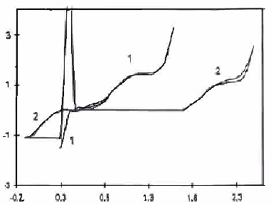
Current density, mA/cm²
Potential, V vs. SCE

Figure 8. Cyclic voltammetry for BDD and Pt electrodes in 1 mM Hg₂(ClO₄)₂/1 M HClO₄.
A very broad anodic silver stripping peak was observed. It was found that subsequent sweeps resulted in smaller peaks, which indicates that smaller quantities of silver are stripped from the electrode surface. Moreover, the cathodic charge for silver deposition is repeatedly much higher than the corresponding anodic charge in 4
M HNO₃ or 1 M HClO₄ solutions. In situ optical microscopic observations indicated dendritic growth of silver and its weak adhesion to the diamond surface. Mercury deposition was also reported to be similar to that of silver. Figure 8 shows the CV of BDD and Pt electrodes in 1 mM Hg₂(ClO₄)₂/1 M HClO₄.
It has been reported that mercury nucleation occurs following the onset of the potential step on a relatively small number of active sites, which are exhausted at an early stage of the process. Formation of calomel (Hg₂Cl₂) in the presence of trace chloride was also discussed. Finally, the incomplete stripping was explained due to the non-uniformity of boron doped diamond electrode.

2.1.3. Gold

Tetrachloroaurate(III) dissolved in dilute aqueous aqua regia is electrochemically reduced at boron-doped diamond electrodes to form gold metal [42].
Figure 9 shows three consecutive voltammograms obtained for the reduction of 0.5 mM AuCl₄⁻ in dilute aqua regia at a freshly deposited 1-mm diameter boron-doped diamond electrode. Reduction commences at 0.47 V (vs. SCE), for the first scan with a reduction peak at 0.3 V (vs. SCE), corresponding to the reaction given in the following equation:
AuCl₄⁻ + 3e⁻ → Au° +4Cl⁻ (2.1)
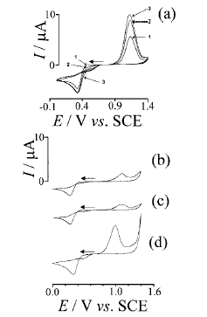

Figure 9. Three consecutive voltammograms obtained for the reduction of 0.5 mM AuCl₄⁻ in dilute aqua regia at a freshly prepared, as-deposited 1-mm diameter BDD electrode.

  - Trace metal deposition

Recently, Manivannan et al. demonstrated for the first time that diamond electrodes can be used for toxic trace analysis without the help of mercury, which is typically coated on electrode surfaces such as glassy carbon or iridium to improve the response. This approach leads to a mercury-free electrode for trace metal detection. In the conventional mercury-based procedure, metals are accumulated in dissolved form in the liquid mercury, whereas, with the boron-doped diamond electrodes, the metals are deposited in solid form on the electrode. The mercury-free detection of lead at levels below 1 ppb has been demonstrated at a bare diamond electrode [27, 28, 30].
In initial work, carried out with relatively high lead concentrations, simple CVs at the diamond electrode were measured. As we can see in Fig. 10, a large cathodic deposition peak and a small anodic stripping peak were observed. This indicates that the deposited lead metal was not completely stripped from the diamond surface. Moreover, consecutive scans show further decreases in the magnitude of the cathodic deposition peak.
This work thus concluded that, under some circumstances, specifically, at high metal concentrations in solution, it is difficult to use the anodic stripping technique for the quantification of metals at diamond electrodes. Our results, in which the Pb was not completely stripped from the electrode during a single anodic scan, are in agreement with results reported by others [33, 43]. All have reported that there is excess charge for the cathodic deposition compared to the anodic oxidation. Figure 10 is a good example for a similar situation.
Although this phenomenon has not yet been completely explained, one likely explanation is that the deposited particles may only be weakly attached to the hydrophobic, hydrogen-terminated surface [44] or only well attached at specific nucleation sites[45, 46].
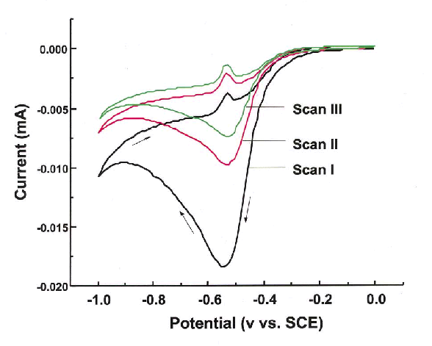
Figure 10. Cyclic voltammogram for Pb (NO₃)₂ (10⁻⁶ M) in 0.1 M KCl (pH 1) at a boron-doped diamond (BDD) electrode. This CV indicates a significant unbalanced charge of the cathodic anodic waves. A small amount of Pb is being stripped compared to the amount deposited.
We have found that, if the particles are large enough to be visible by scanning electron microscopy (SEM) (i.e., > 0.1 µm), they are too large to be completely oxidized during the positive voltammetric sweep. This can be explained by the model shown in Fig. 11.
As shown subsequently, however, at relatively low lead concentrations, i.e., those of most interest for public health, we have shown that is possible to deposit and quantitatively strip small amounts of lead, demonstrating the feasibility of trace analysis.

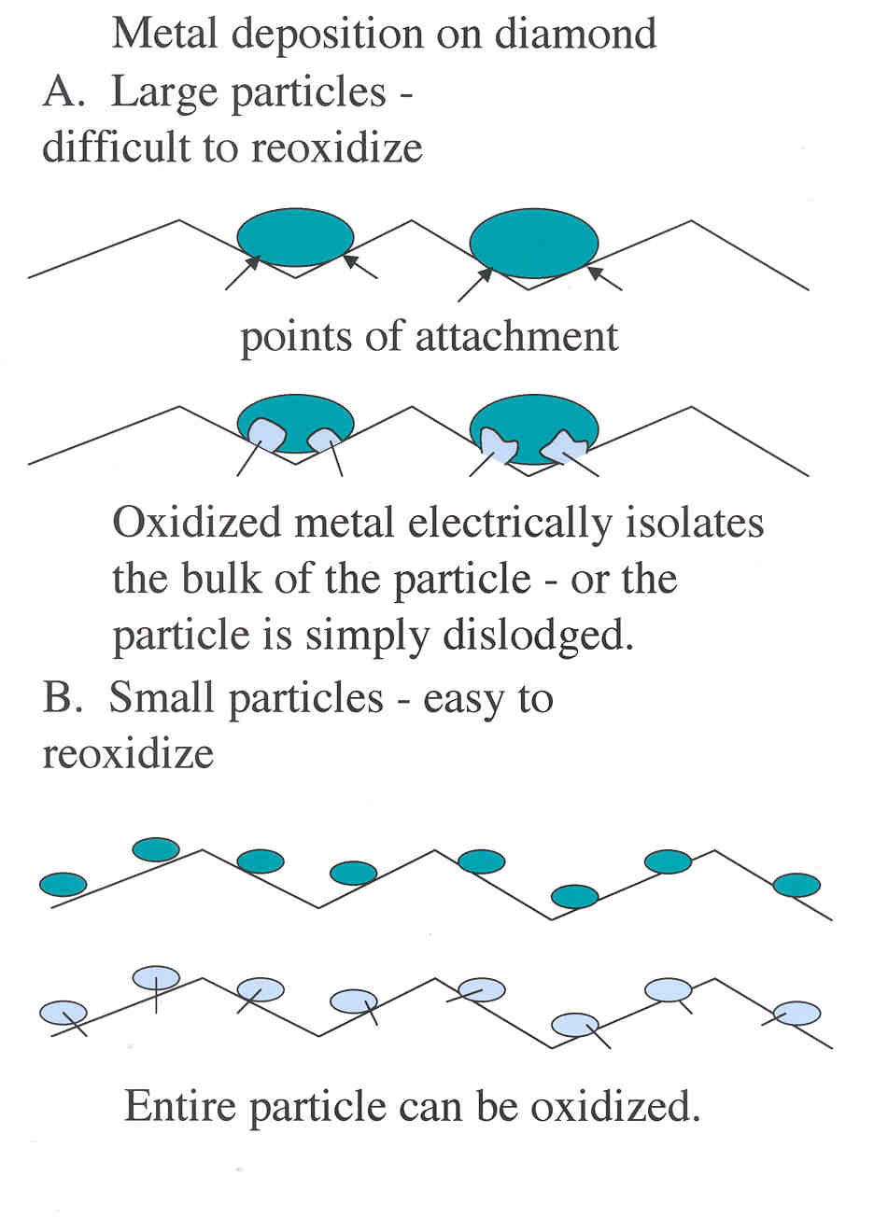
Figure 11. Model explaining the observed behavior for metal deposition on diamond.
An SEM image (Fig. 12) shows the morphology of the metallic lead that deposits on the diamond surface when the solution concentration is relatively high. Lead was deposited for 2 minutes (Fig. 12c) and 10 minutes (Fig. 12d) at -0.7 V vs. SCE. It is clear that metal islands deposit on the BDD crystal planes as well as on the grain boundaries. It should be noted here that these metallic deposits are of the type that cannot be quantitatively stripped.
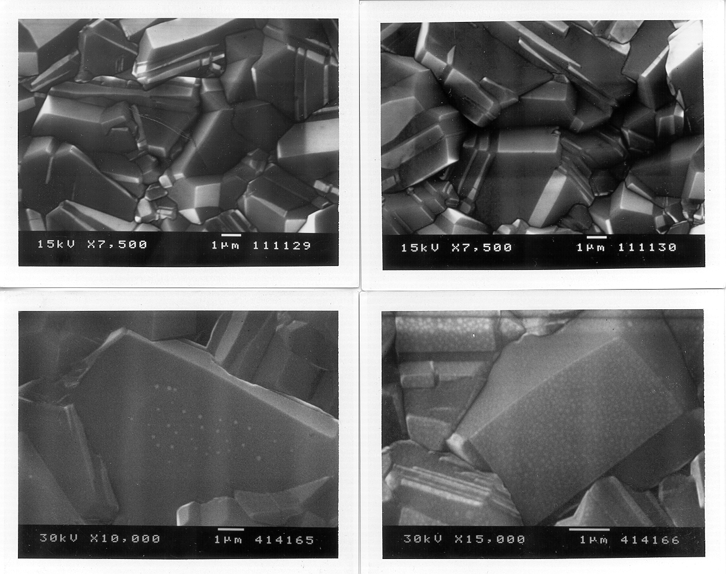
a
c
d
b

Figure 12. (a,b) SEM images of bare BDD; (c) electrochemical nucleation of lead metal is observed; (d) lead deposited electrochemically all over the diamond facets.
In anodic stripping voltammetry, however, it is a requirement that the deposited metal be completely removed from the electrode surface. As we found subsequently, it is possible to achieve quantitative stripping when the solution concentration is small. As an example, Fig. 13 shows consecutive stripping scans for lead on BDD for a solution of 0.1M KCl (pH=5).
Figure 13. DPV scans of 1.5 × 10⁻⁶ M lead on BDD (a) after 3 minutes of deposition at –1.0 V vs. SCE, (b) without deposition.
The first scan was performed after the deposition of lead at -1V vs. SCE for three minutes, and the second scan was performed immediately following the first scan, without deposition. It is clear that the lead deposited on the BDD surface has been mostly removed. The small peak that appears in the second scan is due to the deposition of some lead when the scan starts from -1V vs. SCE.

3. Recent Work

3.1. Single metal analysis

3.1.1. Lead

The new approach of mercury-free analysis of trace metals using BDD electrodes proposed by Manivannan et al. indicated in the previous section will be discussed in detail in this section. In the first implemenation of this approach, a differential pulse anodic stripping voltammetry (DPASV) experiment was carried out at submicromolar Pb(NO₃)₂ concentrations at diamond electrodes in 0.1 M KCl (pH 1) [29]. Deposition involved holding the potential at -1.0 V vs. (SCE) for 2 min. Figure 14 shows the DPASV curves obtained for several Pb concentrations from 4 x 10⁻⁷ to 2 x 10⁻⁶ M in 0.1 M KCl (pH 1) following deposition.
Figure 14. DPASV for Pb(NO₃)₂ in 0.1 M KCl (pH 1), obtained for the BDD electrode after holding the potential at –1.0 V vs. SCE (saturated calomel electrode) for 2 min. The concentrations were (a) 2 × 10⁻⁶ M; (b) 1.6 × 10⁻⁶ M; (c) 1.2 × 10⁻⁶ M; (d) 8 × 10⁻⁷ M (e) 4 × 10⁻⁷ M; and (f) background. The sweep rate was 20 mV s⁻¹, the pulse amplitude was 100 mV, and the sampling time was 10 ms.
A monotonic increase in the stripping peak current was observed with increasing concentration (Fig. 15).
Figure 15. Linear plot of the differential current vs. concentration of Pb ²⁺ (data from Fig. 14).
The linearity observed here and in previous studies on Pb validates the potential usefulness of this technique for quantification. A concentration of 4 x 10⁻⁹ M was detected with different measurement conditions (Fig. 16), specifically, linear sweep voltammetry (LSV) instead of DPV. Three differences in the two experimental results should be noted. First, although the peak potentials are similar (-0.53 to -0.51 V in Fig. 16 and -0.52 V in Fig. 14), the onset of current occurs at a more negative potential, and the current minimum occurs at a much more positive potential in Fig. 14 compared to Fig. 16, i.e., the peak width is much larger (0.125 V in Fig. 16 vs. 0.045-0.065 V in Fig. 14). Second, although the concentration in Fig. 16 is a factor of 100 lower than the lowest concentration in Fig. 14, the background-corrected peak current (~0.3 µA) is only a factor of ~5 lower (~1.4 µA). There is only a factor of 2.5 difference in the deposition times (2 vs. 15 min). Both of these differences are related to the higher sweep rate. The increased peak
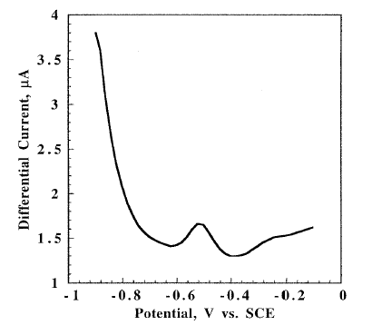
Figure 16. Linear sweep voltammetric scans for lead (4 × 10⁻⁹ M Pb) in water.
width may be ascribed to kinetic factors [47], and the increased relative current can be ascribed to the simple linear relationship expected for peak current (sweep voltammetry) vs. concentration for a surface-bound redox couple [48]. Finally, there is a lower magnitude, broader peak at more positive potentials in both figures. This peak is shifted to more positive potentials in Fig. 14, probably also due to the increased sweep rate. The origin of this peak is, at present, unknown. Both LSV and DPV are equally sensitive techniques. However, in the case of LSV, we have found that it is sometimes difficult to strip all of the metal deposited on the BDD surface.
There are several possible reasons to expect lower detection limits on diamond electrodes in comparison to mercury electrodes: (i) the intrinsic double-layer capacitance for diamond (~2 to 15µF cm-2) [49, 50] is significantly lower than that for mercury (~10 to 30µF cm-²);17 (ii) the peak current dependence upon sweep rate is usually to the square root with mercury, due to diffusion within the mercury itself, whereas it should be linear with sweep rate for a solid electrode like diamond;18 and (iii) due to the much greater degree of resistance to oxidation of diamond, it is possible to use much more severe pulsing conditions, e.g., larger pulse amplitudes and sweep rates.
Ramesham et al have shown the analysis of mM concentrations of lead, copper, cadmium and silver using differential pulse voltammetry [51]. Various groups [35], including ours [52, 53], have examined the deposition of metals at diamond electrode surfaces for electrocatalysis applications.
Figure 17 shows ASV results for several Pb concentrations obtained with the LSV method [54]. The detection limit was ca. 2 nM (ca. 400 ppt). This is sufficiently sensitive for public health applications, considering that the maximum allowable concentration in drinking water is 50 ppb.
Figure 17. Lead detection by use of the linear sweep voltammetric technique shows anodic stripping voltammetric curves for several Pb concentrations. The detection limit is ca. 2 nM (ca. 400 ppt).

    - Mercury

Mercury detection is also extremely important from the standpoint of public health. We have recently carried out studies on the detection of Hg itself at a BDD electrode using cyclic voltammetry (CV) and DPASV. The nature of the electrode material is an important consideration for trace detection. In the past, the determination of mercury in water by anodic stripping voltammetry has been carried out on several types of electrodes, including graphite [55], carbon paste [56, 57], glassy carbon [58, 59], modified glassy carbon [60], gold [61, 62], platinum [63], modified gold [64] and gold-plated glassy carbon [65]. In some of these cases, electrode preparation is necessary, for example, by polishing or chemical modification. A detection limit of 10⁻¹² M has been reported for a modified GC electrode [60]. A detection limit of 5 × 10⁻¹⁴ M has been reported for GC rotating disk electrodes with the addition of thiocyanate as a means of facilitating both deposition and stripping [58, 59]. In this case, careful polishing is required. Reproducibility can be an important issue if electrode pretreatment is used.
Cyclic voltammetric sweeps for three concentrations of Hg²⁺ at a BDD electrode are shown in Fig. 18, together with the background trace, which clearly shows the wide working potential range. The curves for solutions containing mercury show cathodic and anodic peaks due to the reduction of Hg²⁺ and the oxidation of deposited metallic Hg respectively. The apparent charge associated with the cathodic deposition peak is much less than that for the oxidation. This is due to the fact that the deposition process continues out to a relatively negative potential limit (-0.6V vs. SCE) and is enhanced by mass transport as a result of hydrogen evolution. In the absence of anions that form soluble compounds, the relevant reactions are as follows, where SHE is the standard hydrogen electrode [66]:
Figure 18. Cyclic voltammetric sweeps for various concentrations of Hg²⁺ at a BDD electrode [Hg(NO₃)₂ in 0.1 M KNO₃ (pH = 1)]. The concentrations were (a) 1.5 × 10⁻⁷ M; (b) 2 × 10⁻⁷ M; (c) 2.5 × 10⁻⁷ M; (d) 3 × 10⁻⁷ M; (e) 3.5 × 10⁻⁷ M; (f) 4 × 10⁻⁷ M (g) 4.5 × 10⁻⁷ M (h) 5 × 10⁻⁷ M. The background current is also shown at the bottom of the peak. The sweep rate was 20 mV s⁻¹.

Hg₂²⁺ + 2e⁻ → 2Hg E⁰ = +0.79 V vs. SHE, +0.55 V vs. SCE (3.1)
2Hg²⁺ + 2e- → Hg₂²⁺ E⁰ = +0.92 V vs. SHE, +0.68 V vs. SCE (3.2)
Hg²⁺ + 2e- → Hg E⁰ = +0.85 V vs. SHE, +0.61 V vs. SCE (3.3)
However for example, if an anion, e.g., chloride, that forms an insoluble mercury compound is present, the reversible potential will be shifted substantially in the negative direction:
Hg₂Cl₂ + 2e⁻ → 2Hg + 2Cl⁻ (3.4)
E⁰ = +0.27 V vs. SHE, +0.03 V vs. SCE
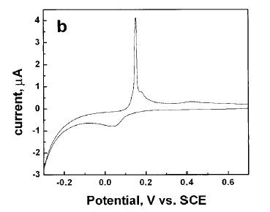
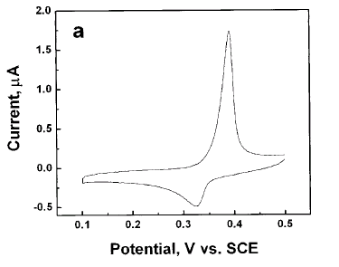

Figure 19. Cyclic voltammetry for (a) high-purity mercuric nitrate [Hg(NO₃)₂ solution (2 ×10⁻⁵ M) in 0.1 M KNO₃ (pH = 1)] as well as (b) the effect of the addition of 1.8 mM of chloride. The mercury stripping peak appearing at 0.4 V vs. SCE in (a) is shifted to 00.18 V vs. SCE in (b).
In the present case, in which chloride is not specifically added to the solution, there will be an intermediate reversible potential that depends on the concentration of chloride as an impurity [67]. It is well known that chloride is a ubiquitous impurity. A separate experiment was carried out with high-purity mercury (II) nitrate, with an upper limit of 0.002% of chloride. Figures 19a and b show the CVs for the high-purity mercuric nitrate as well as the effect of the addition of chloride (1.8mM KCl).
In the high-purity solution, a mercury stripping peak (Hg⁰ to Hg²⁺) is obtained ca. 400 mV. Integration of the cathodic and anodic charge shows agreement within ca.10%, indicating quantitative stripping. In the presence of a known chloride concentration of 1.8 mM, an anodic peak appears at ca. 180 mV, due to reaction 4. This peak can no longer be considered a stripping peak, because the product remains on the electrode surface. Because a non-negligible, adventitious concentration of chloride was present in the measurements carried out in this work (0.002%), the anodic peak was assigned to reaction 4.
It should be noted here that, because the oxidation process involves the formation of highly insoluble product Hg₂Cl₂ (calomel), the electrode must be cleaned carefully with concentrated HNO₃, followed by rinsing with high-purity water. This procedure can perhaps be avoided by use of a thiocyanate-containing electrolyte [68].
CVs for various concentrations of mercury ions are shown in Fig. 18. For a concentration of 3.2 × 10⁻⁶ M, the cathodic peak appeared at ca. 0.12 V vs. SCE and the oxidation peak at ca. 0.23 V vs. SCE. As the concentration was increased to 3.2 ×10⁻⁵ M, a simultaneous stepwise increase in the anodic and cathodic peak currents was observed (Fig. 18). The shift in the anodic peak potentials may be attributed to a kinetic limitation. The shift in the cathodic peak potentials is explained by the fact that, for low dissolved mercury concentrations, the trace level of chloride present tends to shift the deposition in the negative direction due to reaction 3 above. As the mercury concentration increases, there is proportionately less chloride available, which shifts the potential in the positive direction. These effects are less important in the oxidation direction, because the local concentration of mercury would be significantly higher than the trace chloride concentration next to the electrode during stripping. These results show the typical oxidation/reduction processes. The well-defined anodic oxidation peak near 0.25 V is due to stripping of the deposited Hg⁰, whereas the cathodic peak near 0.15 V is due to reduction of Hg²⁺ ions to Hg⁰.
The presence of ionic species such as chloride and nitrate also influences the sensitivity, especially for mercury. The presence of chloride ions actually improves the sensitivity, compared to the case of nitrate alone. We have found the sensitivity and reproducibility can be improved by gold co-deposition method, as explained later. It is important to note that the oxidation process involves the formation of the highly insoluble product Hg₂Cl₂ (calomel), which can adversely affect the reproducibility of the experiment unless the calomel is cleaned from the surface between measurements.

Even without the addition of gold, however, the analysis of trace mercury on BDD electrodes is feasible, however. For comparison with glassy carbon (GC), we have carried DPASV on both BDD and GC electrodes. Figure 20 shows clear evidence for the observation of the mercury stripping peak at the BDD electrode surface, whereas no peak was observed for the GC electrode.
Figure 20. Differential pulse voltammetry curves for Hg(NO₃)₂ solution (6.4 ×10⁻⁷ M) in 0.1 M KNO₃ (pH = 1) electrolyte for a) diamond and b) glassy carbon electrodes. Deposition time was 2 minutes at –0.5 V vs. SCE; pulse amplitude, 50 mV; sweep rate, 100 mV s⁻¹.
In order to validate the ASV method for mercury determination on BDD, a comparison with cold-vapor atomic absorption spectrometry (CVAAS) has also been carried out using a real sample (KCl impinger solution) obtained from the flue gas of a coal-fired power plant. Figure 21 shows the DPASV analysis of the real sample using a BDD electrode. The concentration of mercury in
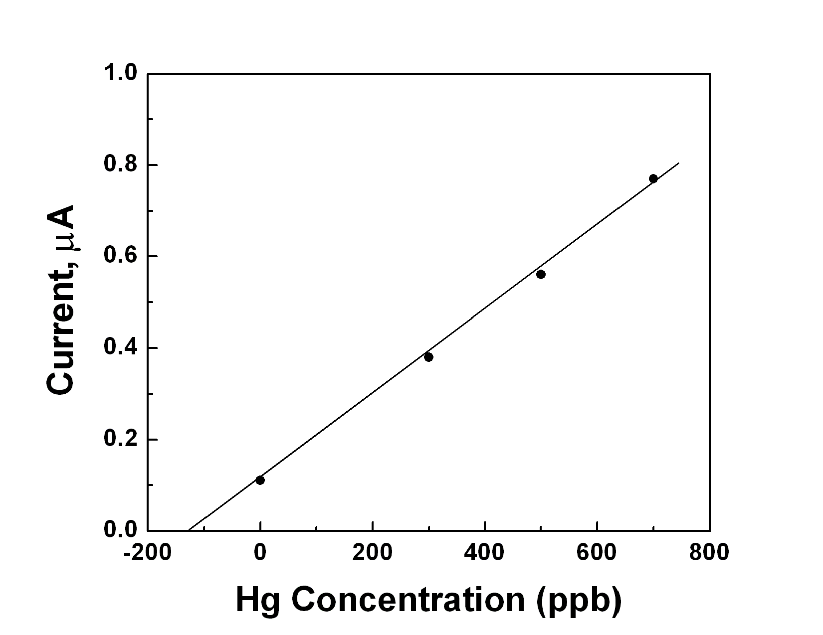
Figure 21. Differential pulse voltammetry for a real sample [supplied by the National Energy Technology Laboratory (NETL)] with three standard additions of mercury solutions, yielding final concentrations of 300, 500, and 700 ppb. An intercept value of 120 ppb was obtained for the unknown mercury concentration. Deposition time, 120 s, at –0.5 V vs. SCE; pulse width, 40 ms; pulse delay, 160 ms; pulse amplitude, 50 mV; sweep rate, 20 mV s⁻¹.
the sample was estimated as 120 ±7 ppb using the standard addition method. A comparison of the same solution by CVAAS indicated a mercury level of 115 ±5 ppb, which agrees well with the value estimated using the diamond electrode.
Figure 22. Calibration curve for DPV peak currents for Hg²⁺ concentrations covering a range from (a) 0-50 ppb and (b) 1 ppb to 10 ppb. Gold standard solution (2 ppm) was added to the electrolyte.
We have thus demonstrated the feasibility of using BDD electrodes for the analysis of mercury and other trace metals. The effect of nitrate and chloride ions is very clearly evident from the cyclic voltammetric analysis. The presence of chloride enhances the stripping peak currents, but it forms insoluble calomel at the surface of the electrode. In order to avoid this problem, we followed a new approach in which a small amount (1-3 ppm) of gold was added to the analyte solution and was co-deposited on the BDD electrode surface. Figures 22a and 22b show the calibration plots for 10-50 ppb and 2-10 ppb of mercury in the presence of a 3-ppm gold standard solution.

3.2 Analysis of two or more metals

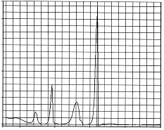
Potential, V vs. SCE
Differential current, μA
Cd
Pb
Cu
Hg
-1.25
-1
-0.5
0
0.5
-1
0
20
40
60
80

Figure 23. Differential pulse anodic stripping voltammetry of a mixture of Zn, Cd, Pb and Cu ions (5 × 10⁻⁷ M) in 0.1 M KCl (pH 1) at a BDD electrode.
In real-world samples, it is common to encounter multiple trace metals of the type that can be detected with anodic stripping voltammetry. As an example, simultaneous multi-element detection analysis of 5 × 10⁻⁷ M Cd, Pb, Cu and Hg by DPSV at a BDD electrode was carried out in our laboratory to demonstrate the fact that the individual stripping peaks can be observed, as shown in Fig. 23.
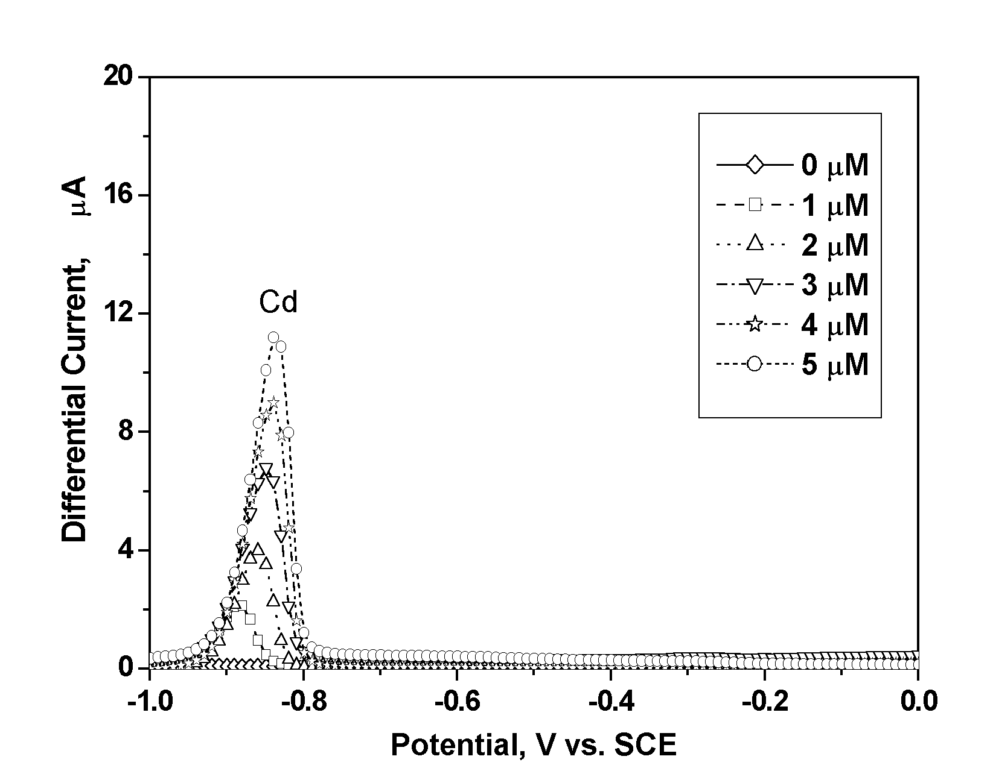
Figure 24. Differential pulse anodic stripping voltammetry curves for the stripping of Cd deposited from solutions containing 1-5 μM Cd(NO₃)₂ in 0.2 M acetate buffer (pH = 5.0); the deposition time was 2 minutes at –1.0 V vs. SCE.
In the analysis of multiple elements with ASV, the use of metallic mercury-electrodes has traditionally been recommended because of the absence of interactions between the metals dissolved in the liquid mercury. With solid electrodes, there is always the possibility of interactions between the deposited metals, because they are deposited in solid form and can thus form alloys, intermetallic compounds, or other types of intermetallic species.
Experiments were performed to try to understand the interactions between Pb and Cd during anodic stripping voltammetric analysis at BDD electrodes. Figure 24 shows the DPASV stripping peaks for Cd deposited from solutions with various concentrations of Cd in acetate buffer (pH 5), with a peak potential of ca. –0.85 V vs. SCE. A linear increase in the differential current with concentration is apparent.
Figure 25 shows the stripping behavior of Cd deposited from various solution concentrations of Cd in the presence of 5 µM of Pb(NO₃)₂. In addition to the Cd stripping peak at –0.85 V, the Pb stripping peak can be seen at –0.65V vs. SCE. In the presence of 5 μM Pb, the peak currents for Cd were consistently ca. 55% smaller than those obtained in pure Cd²⁺ solutions. The decreases in the peak currents for Cd were explained on the basis of the proposed formation of an alloy of Pb and Cd [30].
With the 3D plots, it is now possible to carry out a quantitative analysis for a Pb-Cd mixed solution, even though there is a significant cross-interference. This can be done by means of successive approximations in the following manner. Taking the Cd stripping height peak for an unknown sample containing only Pb and Cd, a horizontal cut would be made on the 3D surface of the plot in Fig. 26a. This would give a range of possible Cd concentrations. This range
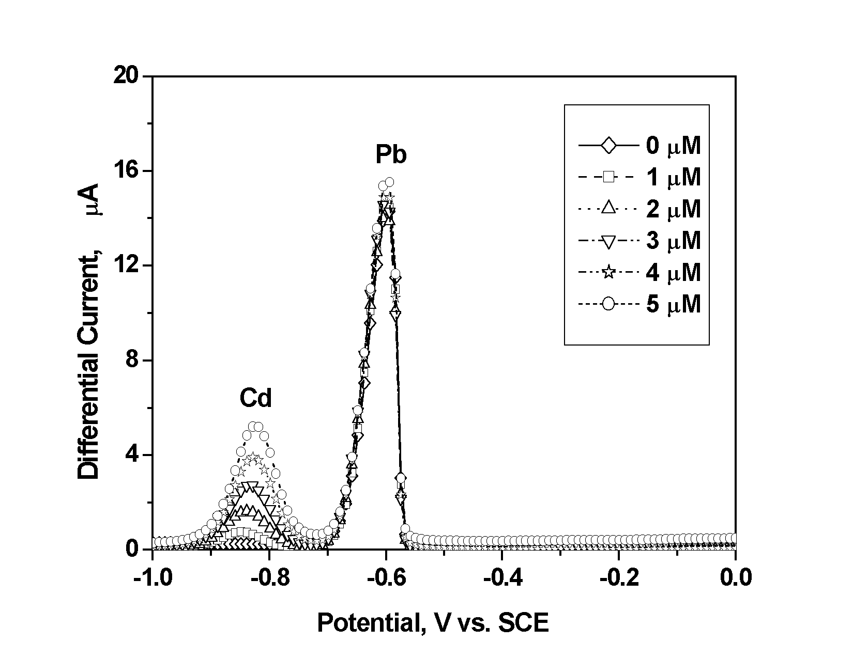
Figure 25. Differential pulse anodic stripping voltammetry curves for the stripping of Cd and Pb from solutions containing Cd(NO₃)₂ in 0.2 M acetate buffer with 5 M Pb(NO₃)₂; the deposition time was 2 minutes at –1.0 V vs. SCE.
would then be used to narrow down the possible range of Pb concentrations that would be obtained from the horizontal cut on the 3D surface of Fig. 26b, obtained from the Pb stripping peak height. The resulting range of Pb concentrations would then be used to narrow down the range of possible Cd concentrations. Working back and forth between the two 3D plots, a good approximation could be made for both concentrations [30].
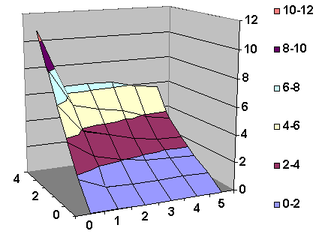
A
Cd peak
Height
(µA)
Cd Conc.
(µM)
Pb Conc. (μM)
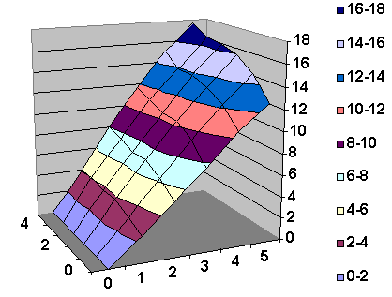
B
Pb peak
Height
(µA)
Cd Conc.
(µM)
Pb Conc. (μM)
Figure 26. Three-dimensional calibration curves for the differential pulse anodic stripping currents for A) Cd and B) Pb in acetate buffer solutions containing both metals.
A commonly encountered combination of metals in water is lead and copper, both being present as impurities due to the water having passed through pipes made from these two metals. Recently, Prado et al., reported the simultaneous detection of lead and copper in aqueous solution using anodic stripping voltammetry (ASV) at BDD [69]. Voltammetry and AFM imaging were used to show that, while both metals nucleate as their pure phases on BDD, the copper nuclei, which form more easily than those of lead, act as favorable sites for the subsequent nucleation and growth of lead; the latter act to inhibit hydrogen evolution on the copper surface. ASV at BDD electrodes provides the basis for a method of independent detection of Cu and Pb via conventional standard addition procedures [36, 39].
Measurements were also carried out in our laboratory to examine the interactions of lead and copper [54]. In our work, which is complementary to that of Prado et al., we have used much lower solution concentrations of the respective metals, down to ca. 10 nM lead, in the presence of various concentrations of copper (0 to 100 nM). Contrary to the results of Prado et al., [69] we observed no evidence for hydrogen evolution catalyzed by copper deposits and thus no evidence for the inhibition thereof with the subsequent deposition of lead. This discrepancy is most likely due to the lower metal concentrations used in our work. The most interesting finding from this work was that, even though lead-copper alloy does indeed form during electrodeposition, it does so predominantly at higher pH, and the mutual interference can largely be avoided by adjusting the pH to low values (pH 1-3). The effect of pH on the anodic stripping linear sweep voltammetry curves for Pb and Cu is shown in Fig. 27.
We also experimented with the use of so-called masking agents, which are designed to form complexes selectively with copper, so that
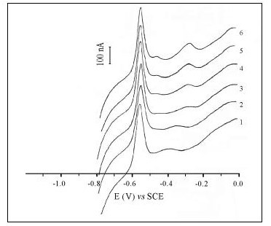
Figure 27. Anodic stripping linear sweep voltammograms obtained with a BDD electrode for aqueous solutions containing lead (10 nM) and increasing amounts of copper: curves 1-6 showing, respectively, 0, 10, 30, 50, 70 and 90 nM. The electrolyte was 0.2 M KCl (pH<2).
the electrodeposition of the latter is impeded. This strategy was found to be promising, with the most effective masking agent being a water-soluble, metal-free porphyrin, which can indeed form a complex with copper much more easily than with lead [54].

- Special Techniques

In this section, we will describe some of the special techniques that are used for trace metal detection in order to improve the sensitivity. These techniques are based on the use of the following modifications: i) the rotating ring disk electrode; ii) ultrasonic enhancement of mass transfer; and iii) microwave enhancement. Finally, a new technique, called abrasive stripping analysis, which can be used to identify and quantify solid materials, will also be discussed.

  - Rotating disk electrodes

Rotating disk electrodes have been used for many years in electrochemistry in order to enhance and better control the hydrodynamics [70]. The use of such electrodes in ASV analysis has also been pursued for a number of years, because it can lead to both higher sensitivity and higher precision. When the electrode is rotated rapidly, the hydrodynamic flow pattern of the electrolyte containing metal ions occurs, enhancing the convection during the reduction of metal ions and deposition of metal on the disk electrode. The mass transfer rate is increased, so that the amount of metal deposited is increased compared to that deposited from a quiescent solution. After the deposition, any of the previously mentioned sweep or pulse techniques can be used to strip the metal. The sensitivity of the measurement is increased simply due to the increased amount of metal that is deposited, which yields a larger stripping charge.

Figure 28. Schematic diagram showing a rotating disk electrode with hydrodynamic flow pattern of the species and the bottom view of the rotating disk electrode (RDE) and the rotating ring disk electrode (RRDE).
However, during the stripping, the electrode rotation can also help to improve the sensitivity by enhancing the mass transport of the oxidized metal ions into the bulk solution.
Figure 28 shows a diagram of the rotating disk electrode with hydrodynamic flow pattern of the solution species, a bottom view of the rotating disk electrode (RDE), and the rotating ring-disk electrode (RRDE). The RRDE is a modified RDE in which the disk electrode is
encircled by a ring, which can function as a second working electrode.
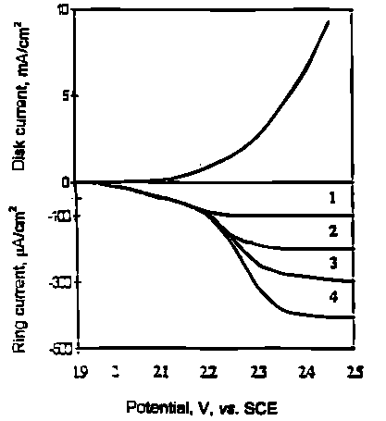
Figure 29. Schematic explanation of the fact that the ring current appears to correspond to the mass transport-limited wave for silver formation at the diamond disk electrode.
Here, the stripped metal ions from the disk electrode can be monitored again, i.e., by measuring the reduction current, as they pass over the ring by laminar flow. This method further increases the detection sensitivity. Electrodes such as gold, platinum, glassy carbon have been used widely as RDEs and RRDEs. Currently, BDD has also been used as a disk electrode [70-72].
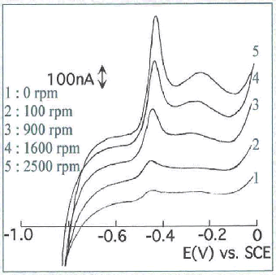
Vinokur et. al. showed that a diamond disk combined with gold rotating ring-disk electrode (RRDE) confirmed the formation of higher

Figure 30. Linear sweep voltammtery curves for 2 nM lead solution using a rotating disk electrode.
valent silver in a silver nitrate-nitric acid solution. This was performed when the diamond potential scan was positive while the ring potential was held at values above the oxygen reduction potential. During this time higher valent silver species alone were detected. Figure 29 shows the ring current, which appears to correspond to the mass transport limited wave for silver (II) formation at the diamond disk electrode [38].
Our group also used diamond RDE electrodes for the determination of lead. The use of rotating electrodes showed that a factor of ca. 10 enhancement in the stripping current was realized. Linear sweep voltammetry curves for 2 nM lead solution using a RDE are shown in Fig. 30. The increase in the stripping peak current is evident with an increase in the rotation speed [73].

  - Ultrasonic techniques

Saterlay et al, investigated ultrasonically-assisted cathodic stripping voltammetry (CSV) at a boron-doped diamond electrode, for the detection of lead. The electrochemical cell used for this work, described in detail previously [74], is shown in Fig. 31.
Square-wave sono-CSV was employed to obtain a response for Pb²⁺ in river sediment. Additions of an aqueous lead standard were then performed; the corresponding electrochemical responses for the sample and the standard additions are shown in Fig. 32. Extrapolation of the stripping currents resulting from the lead additions, facilitated the quantification of lead in the acid digest, and hence a lead content of 187.1 mg/kg was calculated for the sediment sample.
It has been demonstrated that the application of power ultrasound both increases the efficiency of the electrochemistry taking place and, through continuous electrode activation, reduces the chances of electrode fouling from possible adsorption of organic species.

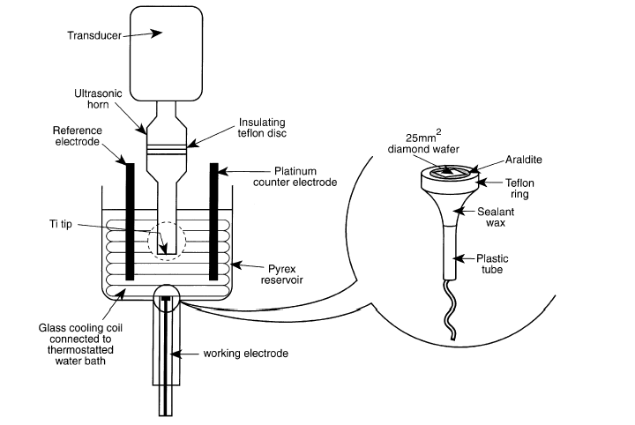
Figure 31. Schematic diagram of the electrochemical cell used in the sono-cathodic stripping voltammetry experiments. Inset: construction of BDD electrode housing.
Similarly, a study of the sono-electroanalysis of silver at a highly boron-doped diamond electrode was presented [75]. Both cathodic and anodic stripping voltammetry have been investigated in terms of their analytical suitability towards silver detection. Cathodic stripping voltammetry, via electrodeposited silver oxide, was affected by the unusual chemistry of the highly oxidizing Ag²⁺ species and the
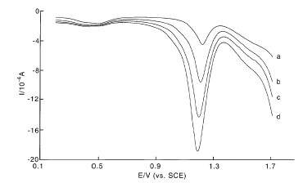
Figure 32. Square-wave sono-cathodic stripping voltammogram showing the response obtained for lead from the sono-acidic digestion of a river sediment sample (a) and: (b) after the addition a Pb²⁺ standard to 1 mM, (c) after the addition a Pb²⁺ standard to 2 mM, (d) after the addition a Pb²⁺ standard to 3 mM. Experimental parameters: insonated electrode cleaning for 120 s at 0.0 V, insonated electrode preconditioning at -1.0 V for a 60-s insonated PbO₂ deposition at +5.0V, electrochemical stripping from 1.5±0.0V at 50 Hz with a step potential of 10 mV and an amplitude of 100 mV.
characterization of this system is discussed in detail. Anodic stripping, via deposition of metallic silver on the bare boron-doped diamond electrode surface under ultrasound, coupled with square-wave voltammetry, was successfully employed in the development of a sensitive technique for the analysis of trace silver ions. A detection limit for Ag⁺ of 10⁻⁹ M for a 300-second deposition, with a linear range of at least two orders of magnitude, and the beneficial effects of controlling the speciation of Ag⁺ via complexation with chloride ions, are reported.
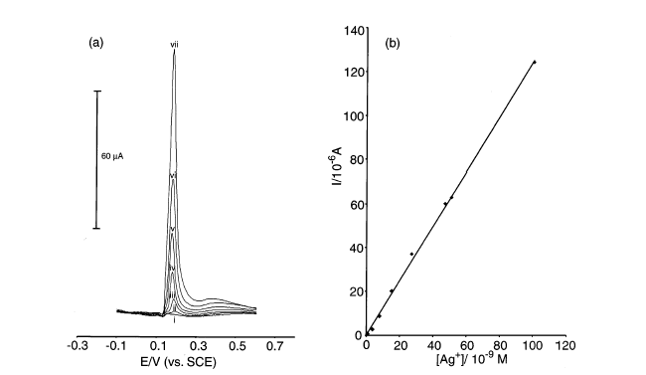
Figure 33. (a) Linear sweep voltammograms (0.0 to +1.0 V (vs. SCE) at 100 mV s⁻¹; step potential, 5 mV) of (i) 10⁻⁹ M, (ii) 3.7 × 10⁻⁹ M, (iii) 8.0 × 0⁻⁹ M, (iv) 1.5 × 10⁻⁸ M, (v) 2.7 × 10⁻⁸ M, (vi) 5.1 × 10⁻⁸ M and (vii) 1.0 × 10⁻⁷ M Ag⁺ solutions in 0.5 M HNO₃ and 12.5 mM KCl, after 300 s insonated deposition (10 mm horn to electrode separation, 14 W cm⁻²) at -0.5 V (vs. SCE); (b) plot of reduction current (I) vs. Ag⁺ concentration for linear scan sono-anodic stripping voltammetry, experimental parameters as in (a).
Current responses for silver stripping were clearly observed at concentrations above 10⁻⁹ M (the practical lower limit of detection for a 300-seconds deposition), with the corresponding voltammograms shown in Fig. 33a. A linear relationship was observed between Ag⁺
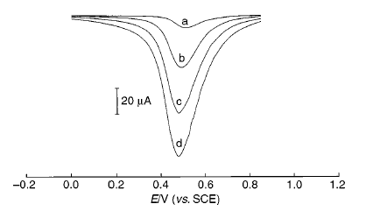
Figure 34. (a) Differential-pulse sono-cathodic stripping voltammogram showing the response obtained for manganese from a solution of PG Tips Pure Tea Granules (100 mg of tea dissolved in 50 mL of water; 125 mL aliquot diluted to 250 mL with 0.5 M NH₄NO₃ [adjusted to pH 7.0 with 10.0 M NaOH]) and (b) after the addition of Mn²⁺ standard to 10⁻⁷ M, (c) after the addition of Mn²⁺ standard to 2 × 10⁻⁷ M and (d) after the addition of Mn²⁺ standard to 3 × 10⁻⁷ M. Experimental parameters: 120 s of insonated MnO₂ deposition at +0.85 V (vs. SCE); insonated-stripping scan (differential pulse) from +0.85 to -0.3 V, step potential = l0 mV; interval time = 0.1 s; modulation amplitude =150 mV; modulation time = 0.02 s; standby potential = 0.0 V.
concentration and signal response over at least two orders of magnitude (Fig.33b).
As another example, sono-CSV was applied for the detection of manganese in instant tea [74]. Differential-pulse voltammetry was used to give the analytical signal from the cathodic stripping of electrodeposited MnO₂; linearity was observed from 10⁻¹¹ M to at least 3 × 10⁻⁷ M, with 10^{-1l} M being the detection limit for a 2-min deposition. The procedure involves both ultrasonic–anodic deposition of MnO₂ and
ultrasonic–cathodic stripping. The differential-pulse sono-cathodic stripping voltammetric technique was used to successfully determine the manganese content of two instant tea samples, giving excellent agreement with independent AAS analyses.
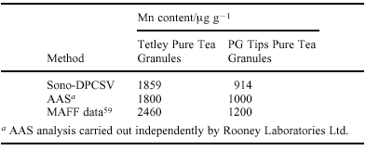
Table 1: Comparison of manganese content in instant tea samples
An example of the corresponding electrochemical responses for the sample and the standard additions is shown in Fig. 34. Extrapolation of the stripping currents resulting from the standard manganese additions facilitated the quantification of manganese in the tea solutions, and hence the manganese content of the tea samples could be calculated (Table 1). The samples were also analyzed independently using atomic absorption spectrometry (AAS), with a good correlation being observed between the sono-DPCSV technique and AAS data [74].
Ultrasound was also applied for short periods of time to prevent the temperature of the solution in the electrochemical cell from rising above room temperature (T = 25 ±5 °C) during gold deposition/stripping and gold colloid formation [42].

  - Microwave techniques

Application of microwaves in electrochemical processes has been recently demonstrated to allow rapid heat pulses [76, 77] or stable high temperature conditions [78] to be applied locally at the working electrode/electrolyte interface in electrochemical systems.
Tsai et al. [79] have adopted the microwave activation of electrochemical processes and have employed it to improve the analytical detection of Pb [80]. The combination of microwave enhancement and boron-doped diamond electrode material has been introduced and explored for analytical procedures recently [76, 81]. It was discovered that both the deposition of Pb metal at negative potential followed by anodic stripping, and the deposition of PbO₂ at positive potential followed by cathodic stripping are enhanced in the presence of microwave activation. This exploratory work is extended here in order to develop a novel electroanalytical technique for the analysis of Pb. The new technique was applied to determine the Pb content in a contaminated river sediment sample.
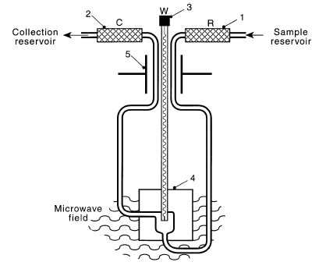
Figure 35. Schematic drawing of the electrochemical cell used for in situ microwave-activated voltammetry. The electrochemical cell consisted of a three-electrode arrangement with a Pt-mesh counter electrode (2), a saturated calomel electrode (SCE, Radiometer) as reference (1), and a special microwave working electrode (3) made of 250-mm diameter platinum wire.
The electrochemical cell used for the microwave enhanced measurements (Fig. 35) consisted of a three-electrode arrangement with a Pt-mesh counter electrode (2), a saturated calomel electrode (SCE, Radiometer) as reference (1), and a special microwave working electrode (3) made of 250 mm diameter platinum wire (Micro Glass Instruments, Greensborough, Victoria 3088, Australia or Scienglass, 46 Witney Road, Long Hanborough, Oxfordshire OX8 8BJ, UK). The working electrode was modified with a 150 mm diameter tungsten
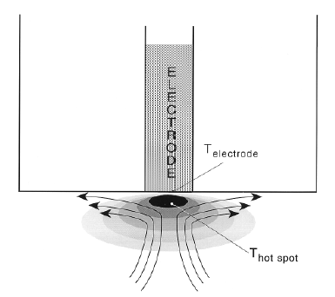
Figure 36. Schematic drawing indicating the combined effect of microwave-induced localized heating and convection on processes at the electrode-solution interface.
rod coated with a boron-doped diamond film (doping level approximately 10¹⁹-10²⁰ cm⁻³) connected to the platinum wire with conducting silver loaded epoxy adhesive and mounted with Torr-Seal [80].
For microwave activation experiments, a modified multimode microwave oven (Panasonic NN-3456, 2.45 GHz) with modified power supply, a water energy sink, and a special port [76, 81] for the
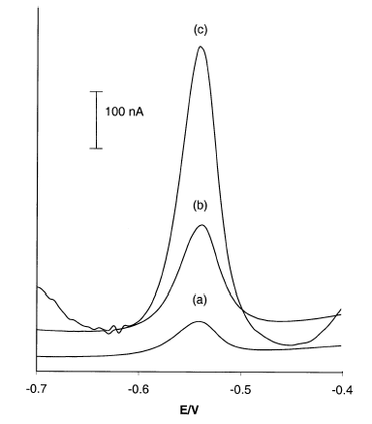
Figure 37. Square-wave voltammetric stripping responses obtained for 2mM Pb²⁺ in 0.1 M HNO₃ at a boron-doped diamond electrode after a 20-s deposition at -1.4 V (vs. SCE) in the presence of microwave radiation [magnetron current a) 0, b) 16, c) 24 mA]. Square-wave voltammetric parameters: frequency, 50 Hz; step potential, 5 mV; amplitude, 50 mV.
electrochemical cell were used. Changing the anode current of the magnetron controlled the microwave intensity.
A schematic drawing of the inverted temperature gradient is shown in Fig. 36 indicating (i) the presence of a high temperature region (about 1-20 m in front to the electrode) and (ii) convective flow
of liquid through the high temperature region towards the electrode surface induced by density changes. It was established that the convective flow induced under these conditions is considerable and accounts for ca. 50% of the observed increase in mass transport.
Stripping voltammetry experiments at a boron-doped diamond electrode with 2 mM Pb²⁺ in 0.1 M HNO₃ have been carried out in order to study the effect of microwave radiation on this process. The square-wave voltammograms for the stripping process after 20 s deposition at -1.4 V (vs. SCE) are shown in Fig. 37 [80] V. It can be seen that microwave activation has a considerable effect on the square-wave stripping response, with signal-to-noise improvements of more than one order of magnitude.
A plot of Pb²⁺ concentration vs. the anodic stripping current (see Fig. 38) shows good linearity and therefore demonstrates the applicability of the boron-doped diamond electrode in the presence of microwave radiation. From Fig. 38, it is also apparent that the current response for the lead stripping process was enhanced by application of microwave radiation at the boron-doped diamond electrode when compared to its absence.
The limit of detection by square-wave voltammetry after a 20-s deposition time was found to be 0.1 mM and 1.0 mM with and without microwave activation, respectively. The Pb content in a water sediment sample detected by anodic stripping voltammetry at boron-
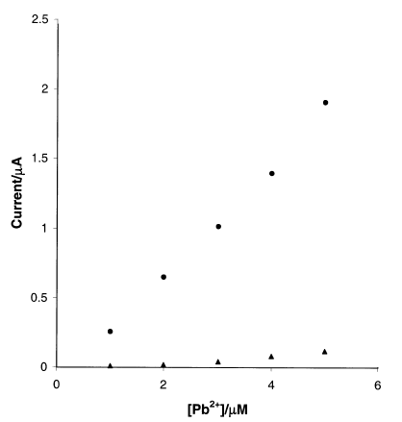
Figure 38. Plot of the square-wave stripping peak current vs. Pb²⁺ concentration after 20 s deposition at -1.4 V (vs. SCE) (●) in the presence of microwave radiation (magnetron current, 24 mA) and (▲) without microwave radiation. Experimental parameters as in Fig. 36.
doped diamond electrodes is shown to be in good agreement with two other independent analytical procedures based on ICP mass spectroscopy and on sono-cathodic stripping voltammetry. Additions of an aqueous lead standard were then performed, and the corresponding stripping peak for the sample and the standard additions are shown in Fig. 39.
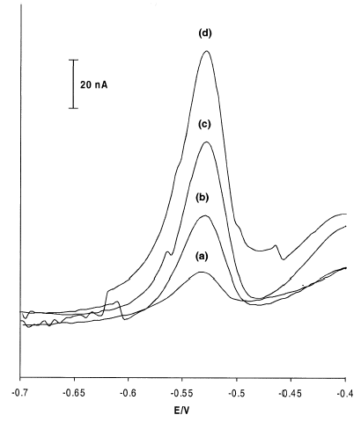
Figure 39. Square-wave stripping voltammogram showing (a) the response obtained for Pb²⁺ after hot-plate digestion of a river sediment sample and (b) after the addition a Pb²⁺ standard to 0.48 mM; (c) after the addition a Pb²⁺ standard to 0.96 mM; and (d) after the addition a Pb²⁺ standard to 1.44 mM. Deposited at -1.2 V (vs. SCE) for 20 s in the presence of microwave radiation (magnetron current, 24 mA). Experimental parameters as in Fig. 37.
Similarly, the effect of microwave on the detection of cadmium in the presence of a nonionic surfactant (Triton X) was also reported [76, 81]. In the presence of the surfactant, Triton X-100, which blocks the electrochemical Cd²⁺ response under conventional conditions, microwave activation is shown to have a considerable effect in enhancing the sensitivity for Cd²⁺ detection.

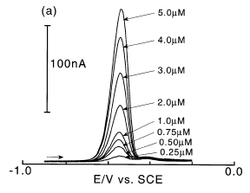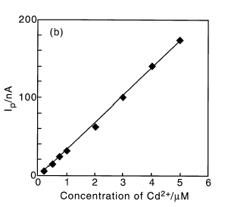
Figure 40. (a) Square-wave voltammetric (50 Hz, 25 mV amplitude, 5 mV potential step) stripping responses obtained for standard addition of Cd²⁺ in 0.1 M acetate buffer (pH 4.7) in the presence of 10 ppm Triton X-100 at a mercury-coated 100 mm diameter Pt disk electrode after a 40-s predeposition at -1.0 V (vs. SCE) (temperature, ca. 328 K determined via calibration with Ru(NH₃)₃⁶⁺). (b) Plot of the peak current versus Cd²⁺concentration.
Square-wave voltammograms obtained for a range of Cd²⁺ concentrations in the presence of Triton X-100 (10 ppm) is shown in Fig. 40a. A plot of cadmium concentration versus peak height (see Fig. 40b) shows good linearity over a wide range of concentrations and therefore demonstrates the applicability of the microwave activation approach.

  - Abrasion techniques

In this section, we present a new approach for the electrochemical identification/fingerprinting of a wide range of materials in trace quantities using abrasive differential pulse stripping voltammetry (AbrDPSV) at boron-doped diamond electrodes. In this study, the abrasive stripping voltammetry of solid metals and alloy samples at diamond electrodes was carried out. The results obtained with brass indicate that the differential pulse voltammogram is an electrochemical fingerprint of the material and can be used to characterize possible interactions between the constituent metals as well as to reveal information on the chemical composition.
It is well known that the extreme hardness, low coefficient of friction and unmatched mechanical strength of diamond render it highly effective for cutting and abrasion. [16, 82] We have demonstrated the superior qualities of diamond as an electrode material for electroanalytical techniques involving abrasive sampling. This is a relatively new technique developed for the qualitative and quantitative analysis of solid materials. Previous studies have employed carbon-based electrodes, for example, wax-impregnated graphite electrodes, for the analysis of soft alloys, minerals and synthetic inorganic compounds. [83-85]. The range of materials that can be sampled is limited by the hardness and friction properties of carbon-based electrodes. The present approach, employing conductive, boron-doped polycrystalline diamond film electrodes, can be used with practically any type of metal, alloy, mineral or compound.
The principle behind abrasive stripping voltammetry (AbrSV) and abrasive differential pulse voltammetry (AbrDPV) involves the mechanical transfer of extremely small amounts of solid materials, by abrasion, from the bulk material to the electrode surface. The deposited material can be simply analyzed by choosing an appropriate voltammetric technique and electrolyte. Polycrystalline diamond, whose deposited surface is rough, consisting of microcrystallites of the order of 1-10 µm, is well-suited for this type of analysis, not only due to its superior abrasive properties but also due to its wide potential window, low background current, and extreme chemical stability. The latter characteristic also enables diamond to be able to withstand large-amplitude potential pulses. [29] Prior to the abrasive stripping measurements, the diamond film sample (~1 cm × 1 cm) was simply rubbed against the metal sample two or three times by hand.
Figure 41a represents the anodic stripping peak for metallic Pb trapped on the diamond electrode in 0.1 M KCl (pH 1) after simple abrasion of the metal sample. The stripping peak for Pb appeared at -0.48 V vs. SCE. Similar measurements were carried out for Fe (Fig. 41b) and brass (Fig. 43). In Fig. 41b, the stripping peak at +0.8 V is clear. The peak width for Fe in this figure (~0.3 V at half-height) is much greater that that for Pb in Fig. 41a (~0.1 V). Such variations of
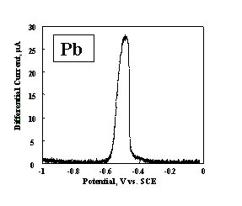
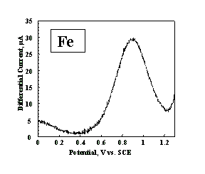

Figure 41. Abrasive differential pulse anodic stripping voltammogram for Pb metal (left), and Fe metal (right) carried out in 0.1 M KCl (pH=1). Potential sweep rate, 20 mV s⁻¹; pulse amplitude, 25 mV; electrode area exposed to the solution, 0.4 cm².
peak width have also been observed by Scholz et al.; narrower peaks are most likely due to facile dissolution in the particular electrolyte [84]. As long as the conditions are the same for repeated experiments, i.e., fresh diamond surface, same pulsing conditions and electrolyte, the stripping voltammograms are highly reproducible. Similarly, AbrDPASV for gold metal has been performed at BDD electrodes. (Fig. 42).
Figure 42. Abrasive differential pulse anodic stripping voltammogram for Au metal in 0.1 M KCl (pH 1).
The stripping behavior for brass particles trapped on the diamond film is shown in Fig. 43. Three peaks are observed, at -0.85 V, -0.02 V and +0.42 V vs. SCE. Based on the stripping behavior of the individual metals, the peak at -0.85 V vs. SCE can be assigned to the oxidation of Zn, while the peaks at -0.02 V and 0.42 V vs. SCE can be assigned to the two sequential one-electron oxidation steps for Cu, which occur due to stabilization of Cu⁺ by chloride [86]. In this case, the peak potentials for the alloy are relatively close to those for the individual metals, e.g., +70 mV in the case of the Cu peaks. For other alloys, this is not always the case [87, 88].
Figure 43. Abrasive differential pulse anodic stripping voltammetry for brass (65% Cu, 35% Zn), carried out in 0.1 M KCl (pH=1). Three peaks are observed, at -0.85 V, -0.02 V and +0.42 V vs. SCE.
Thus, the stripping behavior can represent a fingerprint for the particular alloy, providing information on the types of interactions between the constituent metals. However, as long as the interactions are not too strong, this method can be used to obtain a semiquantitative analysis for the alloy composition. For example, using wax-impregnated carbon electrodes, Scholz et al. examined a series of Pb-Sb alloys, finding monotonic increases in the stripping peak heights with increasing metal concentration [89] [90]. This fingerprint technique can be highly useful in identifying various types of alloys, for example in industrial or forensic applications. In addition, it is attractive in terms of rapid identification (less than one minute after mounting the electrode). Preliminary results for the abrasive stripping of stainless steels, superalloys, and minerals are also encouraging [73]. Abrasive stripping for silver and tin has also been shown in a recent report [91].
Polycrystalline diamond is perhaps the only material that can be used for the abrasion of very hard materials but is also well suited for sampling all types of solids. Thus, the abrasive stripping technique with diamond can be applied widely in the rapid identification of materials and compounds in a number of different fields, including environmental pollution, metallurgy, semiconductors, pharmaceuticals, forensics and agriculture.

- Future Prospects

The future appears to be bright for the further application of BDD electrodes in the analysis of trace metals. Some of the challenges for the future include the following: 1) extension of the ASV technique to a wider range of metals, including those at even more negative potentials and even more positive potentials; 2) achieving a better understanding of the interactions between deposited metals; 3) development of ways to deposit metals in a controlled fashion in order to avoid co-deposition; 4) increasing the understanding of the role of the BDD itself in the deposition process; and 5) development of practical analytical systems for anodic stripping analysis, cathodic stripping analysis and abrasive stripping analysis.

Acknowledgements

This research was supported by the Japan Society for the Promotion of Science (JSPS) Research for the Future Program (Exploratory Research on Novel Materials and Substances for Next-Generation Industries). DOE/NETL, EPA, and DOE/CAST projects are acknowledged.

References

1. M. K. Turkdogan, F. Kilicel, K. Kara, I. Tuncer and I. Uygan, Environmental Toxicology and Pharmacology, 13 (2003) 175.
2. H. M. Dani and P. Kaur, Research Bulletin of the Punjab University, Science, 51 (2002) 1.
3. M .P. Waalkes, Heavy Metals in the Environment, (2002) 121.
4. J. Luo and J. Liu, Guangdong Weiliang Yuansu Kexue, 8 (2001) 25.
5. C. Hanisch, Environmental Science & Technology. (1998) 176A.
6. D. Juresa and M. Blanusa, Food Additives & Contaminants, 20 (2003) 241.
7. A. R. Bakhtiyari, Majallah Ulum-i Daryai Iran, 1 (2002) 37.
8. V. Berg, K. I. Ugland, N. R. Hareide, D. Groenningen and J. U. Skaare, Journal of Environmental Monitoring, 2 (2000) 375.
9. K. C. Bowles and S. C. Apte, Anal. Chem., 70 (1998) 395.
10. E. Debrah, E. R. Denoyer and J. F. Tyson, J. Anal. At. Spectrum., 11 (1996) 127.
11. T. H. Nguyen, J. Bomann, M. Leermakers and W. Baeyens, Fresenius J. Anal. Chem, 360 (1998) 199.
12. J. Wang, D. Larson, N. Foster, S. Armalis, J. Lu, X. Rongrong, K. Olsen, and A. Zirino, Anal. Chem., 67 (1995) 1481.
13. J. Wang, N. Foster, S. Armalis, D. Larson, A. Zirino and K. Olsen, Anal. Chim. Acta., 310 (1995) 223.
14. J. Wang, J. Lu, D. Luo, M. Jiang and B. Tian, Anal. Chem., 69 (1997) 2640.
15. P. T. Kissinger and W. R. Heineman, ed., "Laboratory Techniques in Electroanalytical Chemistry", Marcel Dekker, Inc., New York (1996).
16. J. E. Field. ed. "The Properties of Diamond" , New York: Academic Press (1979).
17. A. T. Collins and E. C. Lightowlers, "The Properties of Diamond", ed. J. E. Field., London: Academic Press. (1979) 79-105.
18. T. Yano, "Electrochemical Properties of Functional Diamond Thin Films", The University of Tokyo: Tokyo (1998).
19. J. C. Angus, H. A. Will and W. S. Stanko, J. Appl. Phys., 39 (1968) 2915.
20. M. Iwaki, S. Sato, K. Takahashi and H. Sakairi, Nucl. Instrum. and Methods,. 209/210 (1983) 1129.
21. Y. V. Pleskov, A. Y. Sakharova, M. D. Krotova, L. L. Bouilov and B.V. Spitsyn, J. Electroanal. Chem., 19 (1987) 228.
22. Y. V. Pleskov, Russian Chemical Reviews, 68 (1999) 381.
23. R. Tenne, K. Patel, K. Hashimoto and A. Fujishima, J. Electroanal. Chem., 347 (1993) 409.
24. T. Reshef and C. Levy-Clement, Israel Journal of Chemistry, 38 (1998) 57.
25. K. Patel, K. Hashimoto and A. Fujishma, Journal of Photochemistry and Photobiology, Anal. Chem., 65 (1992) 419.
26. G. M. Swain, R. Ramesham, Anal. Chem., 65 (1993) 345.
27. A. Manivannan, M. S. Seehra and A. Fujishima, Fuel Process and Tech. (2003) (in press).
28. A. Manivannan, M. S. Seehra, D. A. Tryk and A. Fujishima, Analytical Letters, 35 (2002) 355.
29. D. A. Tryk, A. Fujishima and A. Manivannan, Electrochemical and Solid-State Letters, 2 (1999) 455.
30. A. Manivannan, R. Kawasaki, D. A. Tryk and A. Fujishima, Electrochemica. Acta. (in press).
31. S. Dongchan, D. A. Tryk, A. Fujishima, A. Merkoçi and J. Wang, (Submitted).
32. Z. Peilin, Z. Jianzhong, Y. Shenzhong, Z. Xikang and Z. Guoxiong, Fresnius J. Anal Chem., 353 (1995) 171.
33. A. Mohamad, J. W. Strojek and G. M. Swain, J. Electrochem. Soc., 3 (1995) 142.
34. C. H. Goeting, F. Jones, F. S. John, E. C. John, M. Frank, R. G. Compton, P. R. Chalker and C. Johnston, Journal of Electroanalytical Chemistry, 442 (1998) 207.
35. J. Wang, G. M. Swain, T. Tachibana and K. Kobashi, Electrochemical and Solid-State letters, 3 (2000) 286.
36. J. S. Gao, T. Arunagiri, J. J. Chen, P. Goodwill and O. Chyan, Chemistry of Materials, 12 (2000) 3495.
37. S. Nakabayashi, D. A. Tryk, A. Fujishima and N. Ohta, Chemical Physics Letters, 300 (1999) 409.
38. N. Vinokur, B. Miller, Y. Avyigal and R. Kalish, Journal of Electrochemical Society, 146 (1999) 125.
39. M. C. Granger, J. Xu, J. W. Strojek and G. M. Swain, Analytica Chimica Acta,. 397 (1999) 145.
40. S. Nakabayashi, D. A. Tryk, A. Fujishima and N. Ohta, Chem. Phys. Lett., 300 (1999) 409.
41. J. Zak and M. K. Sadlok, Electrochimica Acta, 45 (2000) 2803.
42. K. B. Holt, S. Genevieve, R. G. Compton, J. S. Foord and F. Marken, Electroanalysis, 14 (2002) 797.
43. F. Marken, Y. C. Tsai, A. J. Saterlay, B. A. Coles, D. Tibbetts, K. B. Holt, C. H. Goeting, J. S. Foord and R. G. Compton, J. Solid State Electrochem., 5 (2001) 313.
44. N. Vinokur, B. Miller, Y. Avyigal and R. Kalish, Journal of the Electrochemical Society, 143 (1996) L238.
45. L. L. Feng, D. Totir, B. Miller, G. Chottiner, A. Argoitia, J. C. Angus and D. Scherson, Journal of the American Chemical Society, 119 (1997) 7875.
46. G. Gunawardena, G. Hills and I. Montenegro, Journal of Electroanalytical Chemistry and Interfacial Electrochemistry, 138 (1982) 241.
47. A. J. Bard and L. R. Faulkner, Electrochemical methods: Fundamentals and applications, New York: John Wiley & Sons, Inc., (1980) 412.
48. A. J. Bard and L. R. Faulkner, Electrochemical methods: Fundamentals and applications, New York: John Wiley & Sons, Inc., (1980) 410.
49. G. M. Swain, Adv.Mater., 6 (1994) 388.
50. K. Honda, T. N. Rao, D. A. Tryk, A. Fujishima, M. Watanabe, K. Yasui and H. Masuda, Journal of the Electrochemical Society, 147 (2000) 659.

51. R. Ramesham, Journal of Materials Science, 34 (1999) 1439.
52. K. Honda, M. Yoshimura, T. N. Rao, D. A. Tryk, A. Fujishima, K. Yasui, Y. Sakamoto, K. Nishio and H. Masuda, J. Electroanal. Chem., 514 (2001) 35.
53. R. Uchikado, T. N. Rao, D. A. Tryk and A. Fujishima, Anal. Chem. Lett., (2001) 144.
54. D. Drago, N. Spataru, R. Kawasaki, A. Manivannan, D. A. Tryk and Fujishima, A. (in preparation)
55. E. A. Viltchinskaia, L. L. Zeigmann and S. G. Morton, Electroanalysis, 7 (1995) 264.
56. Z. Navratilova and P. Kula, Anal. Chim. Acta., 273 (1993) 305.
57. P. Hernandez, E. Alda and L. Hernandez, Fresenius J. Anal. Chem., 327 (1987) 676.
58. S. Meyer, F. Scholz and R. Trittler, Fresenius J. Anal, Chem., 356 (1996) 247.
59. D. Jagner, Anal. Chim. Acta.., 105 (1979) 33.
60. I. Turyan and D. Mandler, Electroanalysis, 6 (1994) 838.
61. I. Svancara, M. Matousek, E. Sikora, K. Schachl, K. Kalcher, K. Vytras, Electroanalysis, 9 (1997) 827.
62. M. Korolczuk, Fresenius J. Anal. Chem., 357 (1997) 389.
63. R. Z. Hassan, D. F. Untereker and S. J. Bruckenstein, J. Electroanal. Chem., 42 (1973) 161.
64. C. Faller, N. Yu. Stojko, G. Henze and Kh. Z. Brainina, Anal. Chim. Acta., 396 (1999) 195.
65. EPA Method 7472, Mercury in Aqueous Samples and Extracts by Anodic Stripping Voltammetry (ASV).
66. P. W. Atkins, Physical Chemistry, Oxford: Oxford University Press, 6 ed. (1998).
67. P. K. Wrona and Z. Galus, Encyclopedia of Electrochemistry of the Elements, ed. A. J. Bard., New York: Marcel Dekker, Vol. IXA. (1976).
68. M. A. Nolan and S. P. Kounaves, Anal. Chem., 71 (1999) 1176.
69. C. Prado, S. J. Wilkins, F. Marken and R. G. Compton, Electroanalysis, 14 (2002) 262.
70. Yu. V. Pleskov and V. Y. Filinovskii, Rotating Disc Electrode(Book written in Russian)., Moscow: Nauka. (1972) 344.
71. V. A. Myamlin and Pleskov, Electrochemistry of Semiconductors. Pelnum, New York, 1967. 410.
72. V. Y. Filinovskii and Yu. V. Pleskov, Compr. Treatise Electrochem, 9 (1984) 293.
73. A. Manivannan, D. A. Tryk and A. Fujishima, unpublished results.
74. A. J. Saterlay, J. S. Foord and R. G. Compton, Analyst, 124 (1999) 1791.
75. A. J. Saterlay, F. Marken, J. S. Foord and R. G. Compton, Talanta, 53 (2000) 403.
76. R. G. Compton, B. A. Coles and F. Marken, Chem. Commun., 23 (1998) 2595.
77. R. P. Akkermans, S. L. Roberts, F. Marken, B. A. Coles, S. J. Wilkins, J. A. Cooper, K. E. Woodhouse and R. G. Compton, J. Phys. Chem. B., 103 (1999) 9987.
78. F. Marken, S. L. Matthews, R. G. Compton and B. A. Coles, Electroanalysis, 12 (2000) 267.
79. F. Marken, S. L. Matthews, R. G. Compton, B. A. Coles and R. G. Compton, New J. Chem, 24 (2000) 653.
80. Y. C. Tsai, B. A. Coles, K. B. Holt, J. S. Foord, F. Marken and R. G. Compton, Electroanalysis, 13 (2001) 831.
81. Y. C. Tsai, B. A. Coles, R. G. Compton and F. Marken, Electroanalysis, 13 (2001) 639.
82. K. E. Spear ed. "Synthetic Diamond: Emerging CVD Science and Technology", New York, (1994).
83. F. Scholz and B. Lange, Trends Anal. Chem, 11 (1992) 359.
84. F. Scholz, L. Nitschke, G. Henrion and F. Damaschum, Fresenius'J. Anal. Chem., 335 (1989) 189.
85. B. Meyer, S. Zhang and F. Scholtz, Fresenius' J. Anal. Chem, 356 (1996) 267.
86. U. Bertocci and D. R. Turner, "Encyclopedia of Electrochemistry of the Elements", ed. A. J. Bard. New York: Marcel Dekker Vol. II. (1974).
87. S. Swathirajan, J. Electroanal. Chem., 221 (1987) 211.
88. F. Elkhatabi, M. Sarret and C. Mueller, J. Electroanal. Chem., 404 (1996) 45.
89. F. Scholz, L. Nitschke and G. Henrion, Naturwissenschaften, 76 (1989) 71.
90. F. Scholz and Meyer, B. "Electroanalytical Chemistry, A Series of Advances", ed. A. J. Bard and I. Rubinstein. New York: Marcel Dekker, 20 (1996) 34.
91. A. Chatterjee, R. Wiltshire, K. B. Holt, R. G. Compton, J. S. Foord and F. Marken, Diamond and Related Materials, 11 (2002) 646.

