Logistic Growth Problems (i.e., Single Populations with Density-Dependence)

*********************5 linked problems************************

1. Turkeys feed on a diet of acorns, fruits and seeds, with their staple being the acorns produced by oak trees. As the turkey populations grow, they may actually be food-limited, such that food per turkey decreases as number of turkeys increases. In such conditions, the future population size may be determined by which of the following equations: (A) , (B) , (C) , (D) , (E) .

2. When acorns are scarce during nesting season, this may force both parents to leave the nest to search for food. An indirect consequence of this would be the need to increase foraging effort to supply the parents and nestlings with food, and increased predation of the nestlings. These low acorn years cause greater density-dependent reduction in population growth because, effectively: (A) N has increased, (B) N has decreased, (C) K has increased, (D) K has decreased, (E) α has increased.

3 If the per capita population growth rate of turkeys is 0 when there are 120 turkeys, and b – d is maximally 8, in a nature preserve, which of the following equations would best describe population growth rate of turkeys with density-dependence (only): (A) , (B) , (C) , (D) , (E)

4. If the nature preserve was managed for maximum turkey harvest by hunters, what population size would be maintained, assuming simple density-dependence alone as the regulator of population growth? (A) 20, (B) 40, (C) 60, (D) 80, (E) 120.

5. One population biologist has described turkey populations as:
•existing in an unpredictable environment
•showing density-dependence
•having a rapid development rate for a bird
•having a relatively long life span, and
•exhibiting iteroparous reproduction

These are life history characteristics of a(n): (A) r-selected species, (B) K-selected species, (C) C-selected species, (D) species with both r- and K-selected attributes, (E) S -selected species
***********************end linked questions*************************

6. Density-dependent effects on population growth can take many forms. If we examine attempts by the human population of western Europe to colonize North America, we see that early attempts made with small groups of people failed (the Vikings, Roanoke Colony, etc.). This could be due to insufficient numbers of people to perform all the functions of a working society, in a situation not unlike introducing too few pack animals (such as wolves) into an area one is trying to colonize. This form of density-dependence is known as:
(A) Resource depletion
(B) Negative density-dependence
(C) Sigmoidal density-dependence
(D) Asymptotic density-dependence
(E) The Allee effect

^^^^^^^^^^^^^^^^^^^^^^^^The following 4 questions are linked^^^^^^^^^^^^^^^^^^^^
An aquarium snail species is subject to typical density-dependent population growth. Birth rate declines with increasing N according to the function b= -0.004N+3.6 and death rate increases with N according to the function d=.001N + 0.2.

7. What is the maximum ‘r’ for this population?
(A) .005
(B) .004
(C) 3.6
(D) 3.4
(E) 0.2

8. What is the carrying capacity of the aquarium for snails?
(A) 680
(B) 1133
(C) 720
(D) 760
(E) K cannot be determined with the information given

9. A young naturalist named Willie is sitting at home one morning, downing a bowl of cereal, when – WHAM! – a wood thrush slams into the dining room window, breaking its wing. Little Willie rescues the stunned bird and places it in a cage. He quickly realizes he will have to feed this bird to keep it alive, so he hops on the internet and reads about what wood thrushes eat. He quickly finds that wood thrushes love to eat…snails! If Willie sets up an aquarium of snails following the density-dependent equations above, how many snails could he maximally harvest in a sustainable fashion from the tank each year to feed the bird? (Assume he keeps them at the optimum N for harvest.)
(A) 340
(B) 578
(C) 680
(D) 920
(E) 1068

10. Willie inoculates his aquarium, with 10 snails purchased from the Exotic Jungle pet store. Given the b and d functions above, how long will it take for the population to reach 200?
(A) 0.328 y
(B) 0.387 y
(C) 0.425 y
(D) 0.861 y
(E) 0.979 y

^^^^^^^^^^^^^^^^^^^^^^^^^^^^^^end of linked questions^^^^^^^^^^^^^^^^^^^^^^^

((((((((((((((((((((((The following 3 questions are linked)))))))))))))))))))))))))))))))
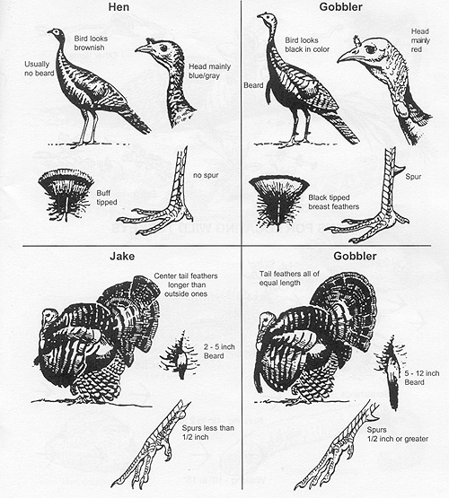
Wild turkeys exhibit density-dependence in which r decreases steadily with increasing N due to increased social interactions and reduced food availability. For a 2500 acre state forest in West Virginia, the functioning relating r to N is: r= 5 - .02N

11. If 20 turkeys were released into this state forest in the year 1995, how many would be found by 2005 if the turkey population followed the density-dependence function described above? (rounded to the nearest whole number)

(A) 21
(B) 125
(C) 245
(D) 249
(E) 250

12. What is the carrying capacity of the state forest for turkey?

(A) 2500
(B) 5
(C) 250
(D) 50
(E) cannot be calculated with the data given

13. If the game warden on the state forest wanted to maximize the sustainable harvest of turkeys, how many turkeys should be maintained in the population?

(A) 5
(B) 20
(C) 25
(D) 125
(E) 642
((((((((((((((((((((((((((((((((((((((((((((((end))))))))))))))))))))))))))))))))))))))))))))))))))

14. Species with indeterminate growth such as many plants change their resource acquisition per individual as they grow, such that the carrying capacity concept (which assumes a constant resource requirement/individual) is no longer valid. For these indeterminate species, a pattern can be seen in their numbers changes over time in which numbers decrease while size increases following a line with -3/2 slope. What is plotted on the X and Y axes of the figure describing the -3/2 thinning rule?

(A) Weight on Y axis, N on X axis
(B) Ln(weight) on Y, N on X
(C) Weight on Y, Ln(N) on X
(D) Ln(weight) on Y, Ln(N) on X
(E) N on Y, Weight on X

&&&&&&&&&&&&&&&&&&More linked problems&&&&&&&&&&&&&&&

15. After five years on the 24 hectare island, the rabbits had multiplied to the point where intense intraspecific competition was occurring. Both direct effects of resource depletion, and indirect effects of increased exposure to predation were occurring as numbers multiplied. Average birth rates had declined and death rates increased with increasing N according to the following functions:

b= -0.01N + 10
d= 0.0001N + 0.2

Assuming logistic population growth, what was the carrying capacity of the island for rabbits?

(A) 112
(B) 970
(C) 1,000
(D) 1,500
(E) 2,000

16. If the population on the island was exactly 525, how many more rabbits would be expected on the island one year later, again assuming logistic population growth?

(A) 28
(B) 136
(C) 445
(D) 475
(E) 961

17. If the rabbit population soared far beyond the sustainable long-term carrying capacity of the island for rabbits (as happened with reindeer on the Pribilof Islands!), which assumption of the logistic was most likely violated?
(A) all individuals reduce growth rate equally
(B) r_{max} is a constant
(C) K is a constant
(D) There is no time lag in response of dN/dt to changing N
(E) Both C and D could explain the population overshoot

18. If a super-smart golden eagle (predator) moved to the island and built a nest, what rabbit population size would the eagle maintain in order to maximize its annual sustainable ‘take’ of rabbits?

(A) K/4
(B) K/2
(C) K
(D) 2K
(E) 10K
&&&&&&&&&&&&&&&&&&&end linked problems&&&&&&&&&&&&&&

