Sample Competition Problems

_________________________linked problem set________________________

These questions are from the 2005 exam. As background, you need to know that previous questions were dealing with Turkeys in a nature preserve called McKereNeil, near Morgantown. McKereNeil has a carrying capacity of 120 for turkeys and the turkeys have an intrinsic rate of increase of 8.

1. McKereNeil is home to ruffed grouse (Bonasa umbellus, another 'game bird'), as well as turkey. Ruffed grouse eat many fruits and seeds, but few acorns, which is the staple food of turkeys. One of the following values equals α, the effect of grouse on turkeys. Which one is it, given the facts above? (A) α = 0.2, (B) α =1.2, (C) α = 1, (D) α = 0, (E) α = - 0.4.

2. If β = α , and Kgrouse = 200, which qualitative outcome of competition would be observed assuming the Lotka-Volterra equations adequately described the system? (A) Grouse would eliminate turkey, (B) Turkey would eliminate grouse, (C) Turkey and grouse populations would reach a stable equilibrium, (D) There would be an unstable equilibrium and either species could win depending on initial N's or r's, (E) This case fits none of the examples shown in class.

3. Again, assuming the Lotka-Volterra equations were predictive, how many turkeys would McKereNeil Woods have after a long period of time? (Rounded to the nearest turkey!) (A) 200, (B) 183, (C) 169, (D) 83, (E) 0.

4. Which of the following generalizations is NOT TRUE concerning competition between grouse and turkey at McKereNeil? (A) The qualitative outcome of competition depends on the competition coefficients and carrying capacities only, (B) The quantitative outcome of competition (specific equilibrium N's) depends only on the competition coefficients and carrying capacities, (C) The initial N's of each species do influence the outcome of competition, (D) The maximum per capita population growth rate does not influence the outcome of competition, (E) None of the above are NOT TRUE: all are true.

5. In areas where they are sympatric, evolutionary forces are likely to result in character displacement for turkey and grouse because: (A) the two species will displace each other from neighboring territories, (B) behavior which is out of character will result in genetic drift, (C) without character displacement, inter-species matings are more likely, (D) individuals that are more different from the other species will leave more offspring, (E) survival will be enhanced by reduction in population size of the other species.
____________________________end of 2005 questions_______________________

++++++++++++++++The following questions are linked++++++++++++++++
A native species of earthworm (species 1) has a maximum r of 0.5, and a carrying capacity of 50 worms per square meter of soil. An invasive introduced earthworm species (species 2) has an r of 0.6, and a carrying capacity of 100 (per square meter). The niches of these two earthworms overlap to some degree, such that α = 0.8 and β=0.6.

6. Which of the following equations best describes the population growth rate of the invasive species, when in competition with the native?
(A)$\frac{{\text{dN}}_{1}}{\text{dt}}=\text{.}5N_{1}(\frac{\text{50}−N_{1}−\text{.}8N_{2}}{\text{50}})$
(B)$\frac{{\text{dN}}_{2}}{\text{dt}}=\text{.}6N_{2}(\frac{\text{100}−N_{2}−\text{.}6N_{1}}{\text{100}})$
(C)$\frac{{\text{dN}}_{1}}{\text{dt}}=\text{.}5N_{1}(\frac{\text{50}−N_{1}−\text{.}6N_{2}}{\text{50}})$
(D) $\frac{{\text{dN}}_{2}}{\text{dt}}=\text{.}6N_{2}(\frac{\text{100}−N_{2}−\text{.}8N_{1}}{\text{100}})$
(E) $\frac{{\text{dN}}_{2}}{\text{dt}}=\text{.}6N_{2}(\frac{\text{100}−N_{2}}{\text{100}})$

7. What would the outcome of competition be after a long period of competition between these two species?
(A) The native would win, and the invasive would be excluded.
(B) The invasive would win and the native would be excluded.
(C) The two species would coexist.
(D) The outcome would depend on the initial starting N’s of each.
(E) The outcome cannot be predicted with the information given.

8. In the absence of the invasive, what would the long-term equilibrium population size be for the native species?
(A) 50
(B) 83
(C) 100
(D) 166
(E) 183

9. If a subset of genotypes within the native species of earthworm exploited a very different niche, and these individuals left more offspring because they competed less with the invasive, what would be expected to happen to the competition coefficients?
(A) α and β would both increase
(B) α would increase, while β would decrease
(C) α would decrease, while β would increase
(D) α and β would both decrease
(E) nothing would happen to α and β; they are constants.

10. If natural selection occurred in the manner suggested in the problem above, how might the probable outcome of change?
(A) the native would be more likely to exclude the invasive
(B) the invasive would be more likely to exclude the native
(C) conditional competitive exclusion would be more likely
(D) it would be less likely the native would ever get established
(E) competitive coexistence would be more likely
++++++++++++++++++++end of linked questions++++++++++++++++++++

%%%%%%%%%%The next four questions are linked%%%%%%%%%%%
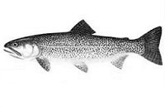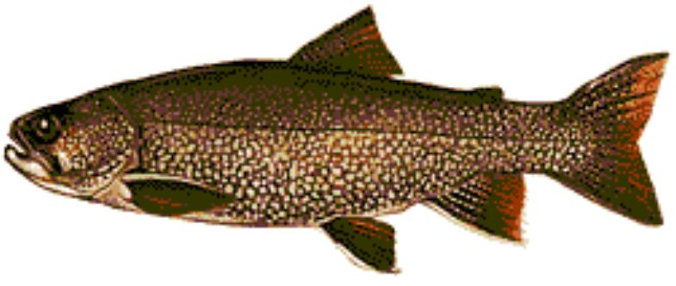
Cutthroat Lake Trout
Cutthroat trout (species 1) and lake trout (species 2) are in competition in Yellowstone Lake. Although both are ‘game fish’ (sought after by fishermen), the cutthroat is native, while the lake trout were introduced and are considered ‘invasive’.

11. The lake trout grows larger than the native cutthroat, so each additional lake trout has a larger effect on cutthroats, than each additional cutthroat. What does this piece of information tell us about competition between the two species?

(A) α > 1
(B) α < 1
(C) α = 1
(D) the lake trout will outcompete the cutthroat trout
(E) the cutthroat trout will outcompete the lake trout

12. Let’s imagine than the competition coefficient describing the effect of cutthroats on lake trout is 0.5 and the competition coefficient describing the effect of lake trout on cutthroats is 4.0. Also, given the smaller size of cutthroats, the carrying capacity of Yellowstone Lake for cutthroats is 2,000,000 while the carrying capacity of the lake for lake trout is ‘only’ 800,000. Which ‘case’ of competition is this?

(A) species 1 wins
(B) species 2 wins
(C) coexistence
(D) conditional competitive exclusion
(E) character displacement

13. If these parameters (K’s and comp. coeffs.) were applicable to the beginning of the lake trout ‘invasion’, let’s imagine there were 1.8 million cutthroats and 10 lake trout were introduced by a misinformed fisherman. What would be the predicted outcome of competition given this initial population size?

(A) lake trout would reach 800,000 and cutthroats would go to 0.
(B) lake trout would reach 500,000 and cutthroats would go to 0.
(C) lake trout would go to 0, and cutthroats would reach 2,000,000.
(D) lake trout would go to 0 and cutthroats would reach 1,600,000
(E) lake trout would reach 200,000 and cutthroats would reach 1,200,000

14. If natural selection within both species favored individuals that were more different from the competitor species in terms of food use within Yellowstone Lake, what prediction could we make about the fish caught in the future in the lake?

(A) both cutthroats and lake trout will be bigger in the future
(B) cutthroats will be smaller and lake trout will be bigger in the future
(C) cutthroats will be bigger and lake trout will be smaller in the future
(D) both species will be smaller in the future
(E) cutthroats will be bigger than lake trout in the future

%%%%%%%%%%%%%%%%%%%end%%%%%%%%%%%%%%%%%%%%%

