Midterm 3
Biology 221, Spring 2010
Form A
Name:_____________________ Clicker Number:________

*Place your name and clicker number on this page
*Carefully bubble in your name, student 700 number, and the form you are using on the answer sheet
*Use a #2 pencil
*You may use a calculator
*There is an equation sheet at the end of the exam for your use anywhere in the test
*Unlike with Dr. McGraw’s clicker quizzes, this exam is to be entirely your work
*Please:
•remove hats 
•close notebooks 
•turn off and put away cell phones
*Answer as many questions as you can by picking the BEST answer
*If you have a question, raise your hand

1. From an ecological standpoint, a population is best defined as:

(A) an interbreeding group of individuals
(B) a group of individuals in a given area
(C) a collection of species in a given area
(D) a collection of species in a given area, plus the environment in which they live
(E) all of the above fit our definition of populations from an ecological standpoint

2. If you wished to quantify how individuals in a population were dispersed across the landscape, you would:

(A) do a mark-recapture experiment
(B) estimate N using the quadrat method
(C) calculate the index, I
(D) calculate D
(E) calculate M

**********************The following 2 questions are linked*****************
A research group in Colorado is interested in quantifying the population of Preble’s Jumping mouse, an uncommon to rare species that is threatened with extinction in some areas. They set out live traps, capturing a total of 68 mice. They place an inconspicuous leg band on each mouse, then set it free in the vicinity of the trap. One week later, the researchers set out 100 traps and catch 52 mice. Thirty-six of these mice are found to have leg bands and 16 do not.
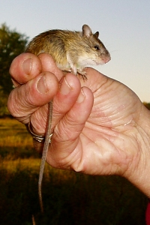

3. How many mice are estimated to be in this population?

(A) 68.00
(B) 76.47
(C) 130.77
(D) 221.00
(E) 98.22

4. The answer to the question above relies on what assumptions?

(A) Preble’s jumping mouse individuals are not ‘trap happy’ (i.e., more likely to be caught the second time around)
(B) Preble’s jumping mouse individuals are not ‘trap averse’ (i.e., less likely to be caught the second time around).
(C) Preble’s jumping mouse populations will have minimal immigration over a 1 week time span
(D) Preble’s jumping mouse populations will have minimal emigration over a 1 week time span
(E) all of the above are assumptions of the estimation method
***********************END OF LINKED QUESTIONS******************

**************THE FOLLOWING 4 QUESTIONS ARE LINKED************
In one particular population of Preble’s jumping mouse, the only factor preventing exponential population growth is domestic house cats from a nearby development. Therefore, the Nature Conservancy, which manages one preserve for the mice, began an aggressive educational campaign to let area homeowners know about the problem. Amazingly, the residents were extremely sympathetic to the plight of the charismatic little mouse, and in 2005, all of them signed an agreement to keep their cats indoors. Subsequently, Preble’s jumping mouse began a period of exponential population growth, as would be predicted if cats had been the only impediment to such growth. Now, birth rates of the jumping mouse reached their maximum value of 4.0, while death rates averaged only 0.5. The following questions concern the growth of the population beginning in 2005.

5. What is the intrinsic rate of increase of this population?

(A) 0.5
(B) 3.5
(C) 4.0
(D) 8.0
(E) cannot be determined with the information given

6. What is lambda (λ) for this population?

(A) 1.25
(B) 1.39
(C) 1.65
(D) 33.1
(E) lambda (λ) cannot be estimated without knowing N(t+1)/N(t)

7. In 2005, the estimated N was 200. If the charismatic mouse kept increasing at an unchecked rate, what population size would be achieved by 2010?

(A) 525
(B) 1,024
(C) 5,688
(D) 3,146,292
(E) 7,964,956,880

8. If the carrying capacity of the preserve was 100,000 mice (but in fact there was no density-dependent regulation of population growth prior to N=K), how many years would it take for the population to reach this number (starting with the 2005 number).

(A) 1.7756 y
(B) 2.3866 y
(C) 3.0016 y
(D) 6.1813 y
(E) it would never reach K.
*********************END OF LINKED QUESTIONS*******************

9. The demographic variable that describes the maximum sustainable population size for a species in a given environment is known as:

(A) r
(B) r_{max}
(C) K
(D) (K-N)/K
(E) a_{ij}

^^^^^^^^^^^^^^^^^^^^^^The following 3 questions are linked^^^^^^^^^^^^^^^^^
A population of coyotes has taken up residency at Coopers Rock State Forest. Predation, hunting, and car accidents have minimal effect on the coyote population dynamics. In addition, since wolves and mountain lions are long gone from Coopers Rock, they are the ‘top dog’ (apex) carnivore. But coyotes do respond to their own densities with territoriality in order to defend resources, so there is a limit to the maximum sustainable population size.


10. Which equation would govern the rate of change of population size, given the scenario described above?

(A) $\frac{\text{dN}}{\text{dt}}=\text{rN}$
(B) $N(t)=N(0)e^{\text{rt}}$
(C) $\frac{\text{dN}}{\text{dt}}=r(\frac{K−N}{K})N$
(D) $N(t)=\frac{K}{1+(\frac{K}{N(0)}−1)e^{−\text{rt}}}$
(E) $N=\frac{\text{nM}}{R}$

11. If the maximum sustainable N for coyotes at Coopers Rock is 100, the current population size is 10, and r_{max} is 0.5, how fast is the population growing?

(A) 2.5
(B) 4.5
(C) 6.3
(D) 12.5
(E) 50.0

12. Theoretically, how long would it take the coyote population to reach its carrying capacity?

(A) 22 y
(B) 47 y
(C) 79 y
(D) 1,028 y
(E) an infinite number of years; the population size approaches K asymptotically.
^^^^^^^^^^^^^^^^^^^^^^^^^end of linked questions^^^^^^^^^^^^^^^^^^^^^^^

13. What phrase best describes why plants do not follow the classic logistic population growth pattern, when followed from establishment through to maturity?

(A) being autotrophic, plants lack a carrying capacity because they assimilate carbon from an essentially unlimited supply in the air
(B) plants exhibit density-dependent thinning due to size-plasticity
(C) plants do not reduce their birth rates when densities increase
(D) plants do not increase their death rates when densities increase
(E) plants do not have an r_{max}

++++++++++++++++++The following six questions are linked+++++++++++++++
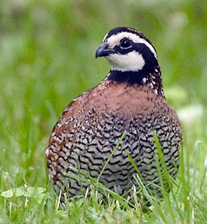
Bobwhite Quail are becoming increasingly uncommon in the eastern United States. Three decades ago, one could here their spring calls - a falling ‘bob…’ and a rising ‘white’, very frequently. A new study has been commissioned to figure out why bobwhites are declining and to look for clues in the age structured population dynamics of this bird. After censusing a cohort of tagged birds for 4 years, the following life table was constructed:

Age (x) | l_{x} | s_{x} | b_{x} | F_{x} | l_{x}b_{x} | For your use | For your use | For your use
0 | 1.00 |  | 0 | 0.4
1 | 0.20 |  | 2 | 2.0
2 | 0.10 |  | 4 | 2.0
3 | 0.05 |  | 4 | 0

14. What is the survival rate of individual bobwhites from age 1 to age 2?

(A) .1
(B) .2
(C) .5
(D) 1
(E) 2

15. How many offspring will the average 3 year old quail have?

(A) 0
(B) 0.2
(C) 0.4
(D) 2
(E) 4

16. Will this population grow, stay the same, or decline, in the long-term?

(A) It will grow; R₀ is >0
(B) It will stay the same; R₀ = 0
(C) It will decline; R₀ < 0
(D) It is impossible to say without more information on birth and death rates
(E) It is impossible to say without knowing the age structure

17. What is the life expectancy of a one-year old bobwhite quail?

(A) 0.85 y
(B) 1.00 y
(C) 1.25 y
(D) 2.75 y
(E) 3.60 y

18. Starting at time t with a population of 28, 14, 6, and 0 in age classes, 0, 1, 2, and 3, respectively, what would the total population size be at time t+1?

(A) 48
(B) 51.2
(C) 66.8
(D) 72.9
(E) 81.1

19. Given your projection in the question above, is the population in a stable age distribution at time t?

(A) Yes
(B) No, because the total numbers changed between year
(C) No, because the proportions in each age class changed between years
(D) No, because bobwhite quails are declining overall
(E) It is impossible to tell whether the population is in a stable age distribution

++++++++++++++++++++++end of linked questions+++++++++++++++++++

&&&&&&&&&&&&&&&Linked Questions&&&&&&&&&&&&&&&&&&

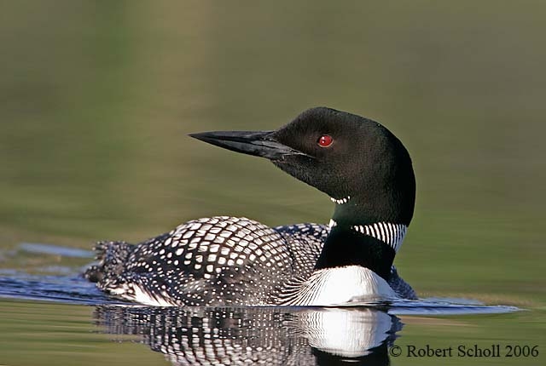
20. There is some concern that cormorants (=species 1; fish eating, diving birds) are competing heavily with loons (=species 2; very beautiful fish-eating, diving birds) in some lakes. If the diagrams below represent the range of fish sizes eaten by cormorants and loons, what can be said about the interspecific competition coefficients for these two species with niches drawn like the curves below?

(A) α = β
(B) α < β
(C) α > β
(D) the relative size of α and β cannot be determined
(E) cormorants are threatened by the presence of the loon, not vice versa

21. A careful study of loon populations found in lakes with and without cormorants shows that when loon and cormorant populations coexist on a lake, the average bill size of the loons is smaller than it is on lakes where they are found singly. What is the most likely explanation?

(A) The Volterra Principle
(B) Character Displacement
(C) r-selection
(D) The Fundamental Theorem of Ecology
(E) The Allee Effect

22. If K₁=K₂/β, and K₂=K₁/α, what is the outcome of competition?

(A) Case 1: Species 1 wins
(B) Case 2: Species 2 wins
(C) Case 3: competitive coexistence at a specific equilibrium
(D) Case 4; either species would win depending on the starting points
(E) None of the above

23. What is ‘limiting similarity’?

(A) That similarity that is at the edge of permitting two species to coexist
(B) That similarity that prevents a species from reaching its carrying capacity
(C) That similarity that differentiates species 1 winning vs. species 2 winning
(D) That similarity which limits a species’ potential to evolve
(E) That similarity that prevents two species from becoming one

24. Based on the findings of researchers at Yellowstone park about the wolf-coyote relationship (and Dr. McGraw’s observations over spring break!), it appears that these two species not only have a competitive relationship, but also a predator-prey one. If this is true, which equation below would best describe coyote population dynamics?

(A) $\frac{\text{dN}}{\text{dt}}=\text{rN}$
(B) $\frac{\text{dN}}{\text{dt}}={\text{apN}}_{1}N_{2}−d_{2}N_{2}$
(C) $\frac{\text{dN}}{\text{dt}}={\text{rN}}_{1}−{\text{pN}}_{1}N_{2}$
(D)$\frac{\text{dN}}{\text{dt}}=r\frac{(K_{1}−N_{1})}{K_{1}}N_{1}−{\text{pN}}_{1}N_{2}$
(E) $\frac{\text{dN}}{\text{dt}}=r\frac{(K_{1}−N_{1}−{αN}_{2})}{K_{1}}N_{1}−{\text{pN}}_{1}N_{2}$

-------------------------------The following 4 problems are linked------------------------
Although Arctic foxes are omnivorous and have a broad diet, their populations seem to fluctuate somewhat in response to lemming population sizes, setting up a classic predator-prey cycle in the far north. Assume that a given fox can catch and kill 0.1% of the population of lemmings, and that it takes the energy and nutrition of 400 lemmings to result in one baby fox birth.
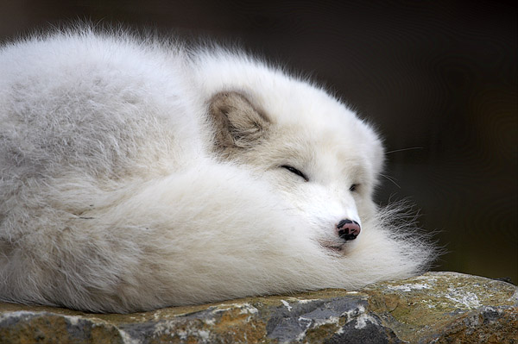

25. If the death rate of the fox is 0.1, at what lemming population size would the fox population not be growing or declining?

(A) 10,000
(B) 20,000
(C) 30,000
(D) 40,000
(E) 50,000

26. If the intrinsic growth rate (r) of the lemming population is 5.0, at what fox population size would the lemming population be unchanging?

(A) 2,000
(B) 4,000
(C) 5,000
(D) 8,000
(E) 10,000

27. If the current population sizes are N₁(t) = 400, and N₂(t) = 20, what direction will the two-species community arrow (the net result) be pointing on a graph of N₁ (x-axis) vs. N₂ (y-axis)? [Assume the top of the paper is north, bottom south, etc.]

(A) northeast
(B) northwest
(C) southwest
(D) southeast
(E) north

28. What would the outcome of the predator-prey interaction be, if Volterra Predator Prey equations determined population growth for a long time?

(A) a neutrally-stable cycle
(B) the populations would cycle in to a point
(C) the populations would cycle in (or out) to a stable limit cycle
(D) the populations would both crash to zero
(E) the populations would spiral out of control

Name: _____________________ Student#___________________

29. In each of the spaces defined by the lines in the graph below, draw arrows showing the direction of population growth in the two-species community and describe in a few words the outcome of interspecific competition.
30. On the graph below, draw the two-population trajectory to its endpoint or its ending cycle (whichever is correct), given a predator (N₂) - prey (N₁) relationship between the two species, no predator satiation, and the prey population growth with density-dependence described by the following modified Volterra equation:
$$\frac{{\text{dN}}_{1}}{\text{dt}}=r_{1}N_{1}(\frac{K_{1}−N_{1}}{K_{1}})−{\text{pN}}_{1}N_{2}$$

